P2.c

Print name using puts

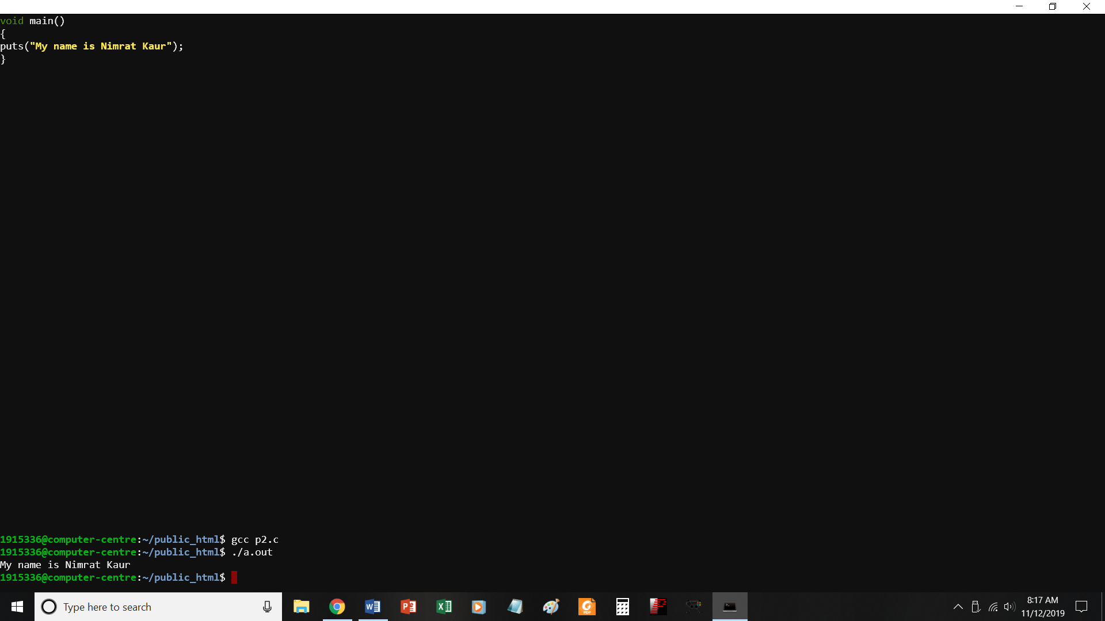

//print name using puts

#include <stdio.h>

void main()

{

puts("My name is Nimrat Kaur");

}

P3.c

Print address of college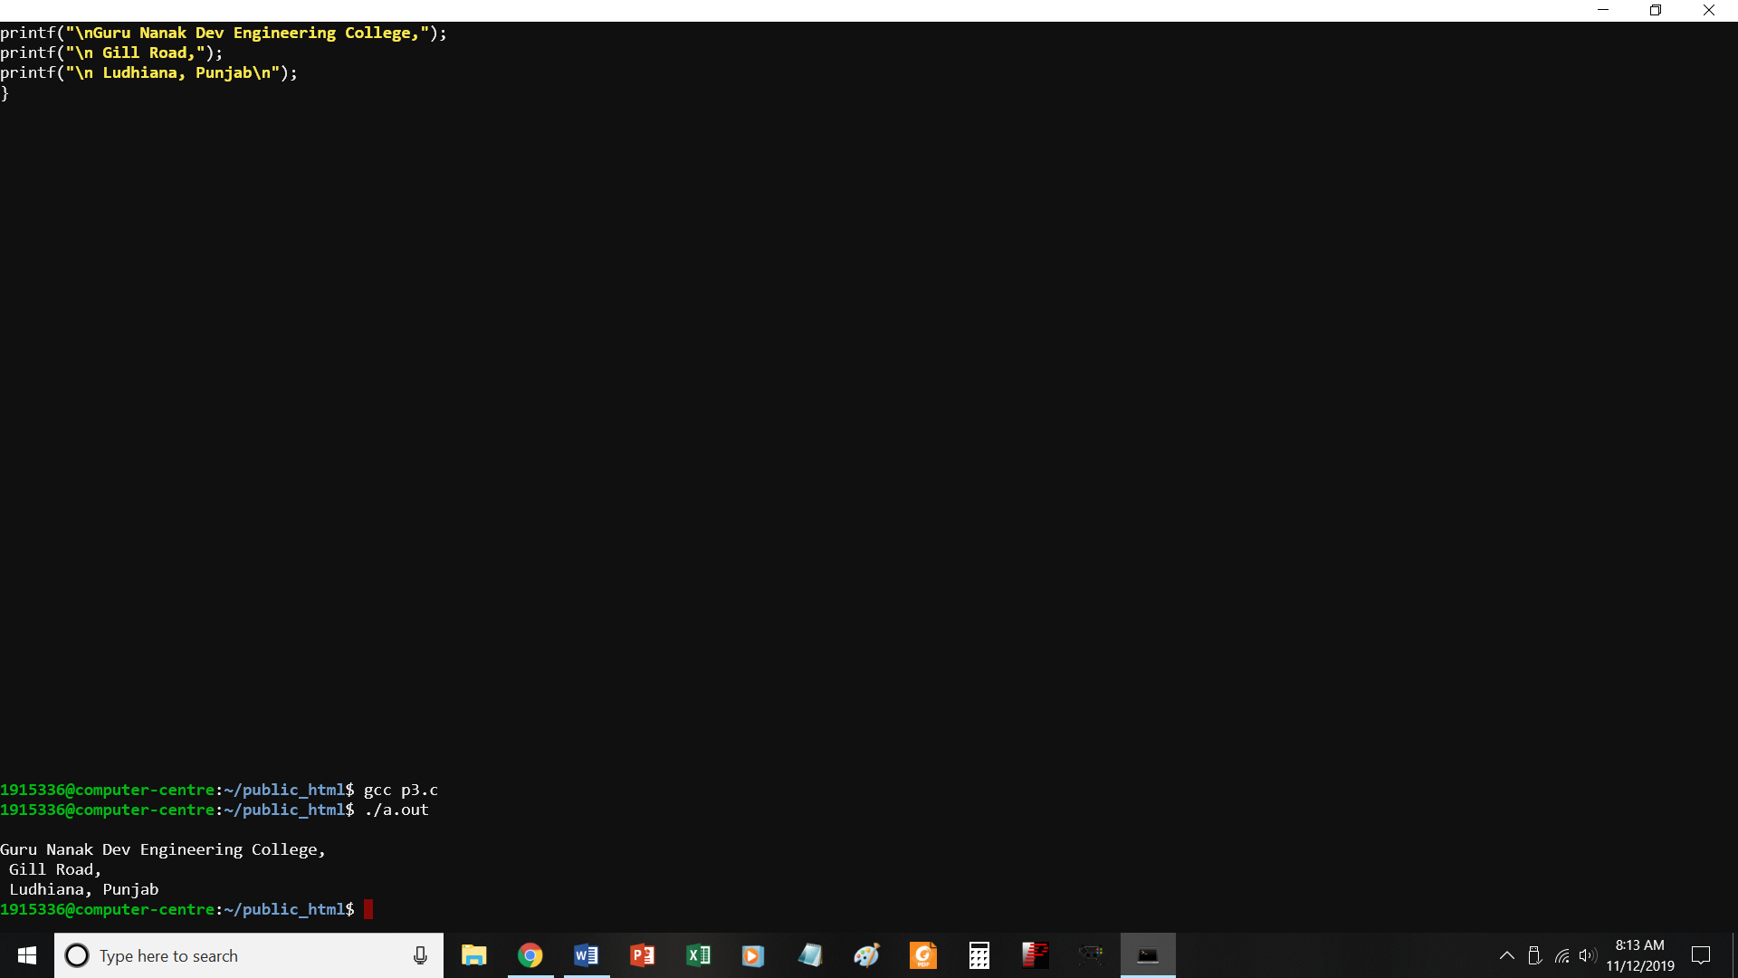

//PROGRAM TO PRINT ADDRESS OF COLLEGE

#include <stdio.h>

void main()

{

printf("\nGuru Nanak Dev Engineering College,");

printf("\n Gill Road,");

printf("\n Ludhiana, Punjab\n");

}

P4.c

Find sum of two numbers

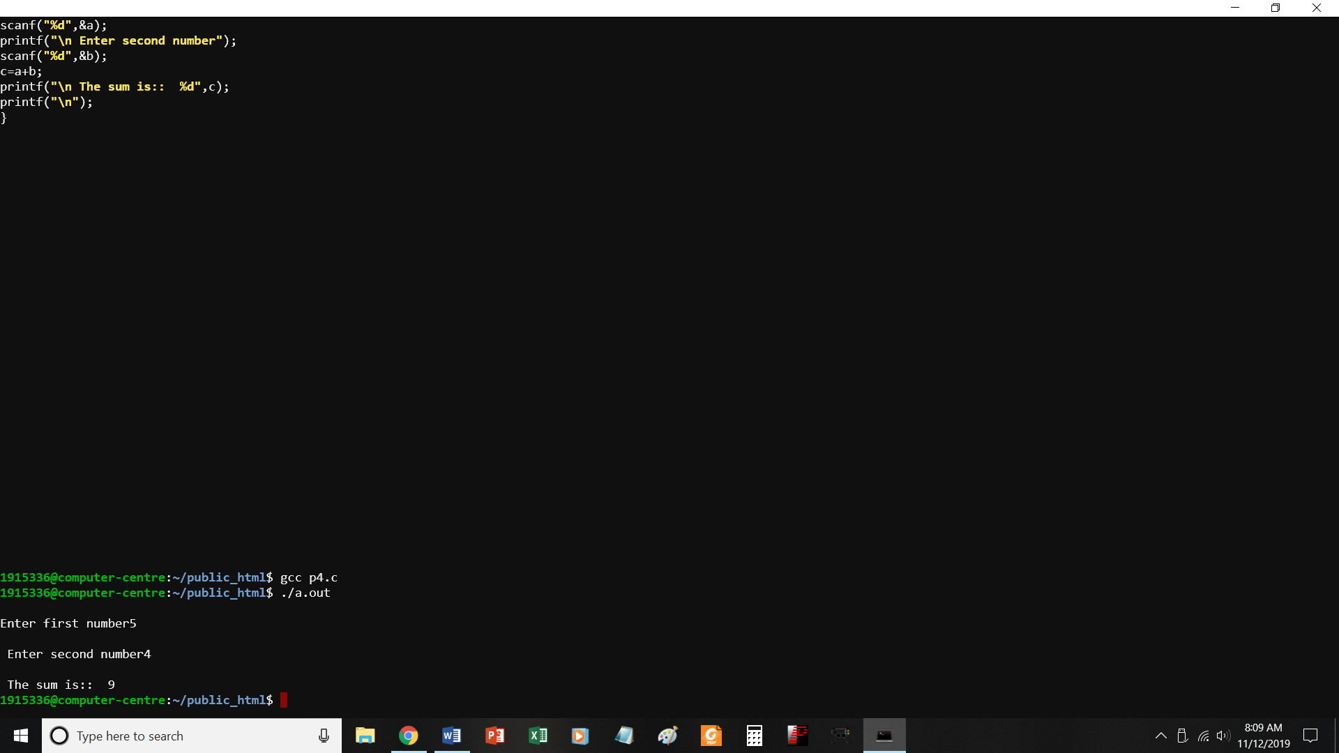

//PROGRAM TO FIND SUM OF TWO NUMBERS

#include <stdio.h>

void main()

{

int a,b,c;

printf("\nEnter first number");

scanf("%d",&a);

printf("\n Enter second number");

scanf("%d",&b);

c=a+b;

printf("\n The sum is:: %d",c);

printf("\n");

}

P5.c

To print quotient and remainder

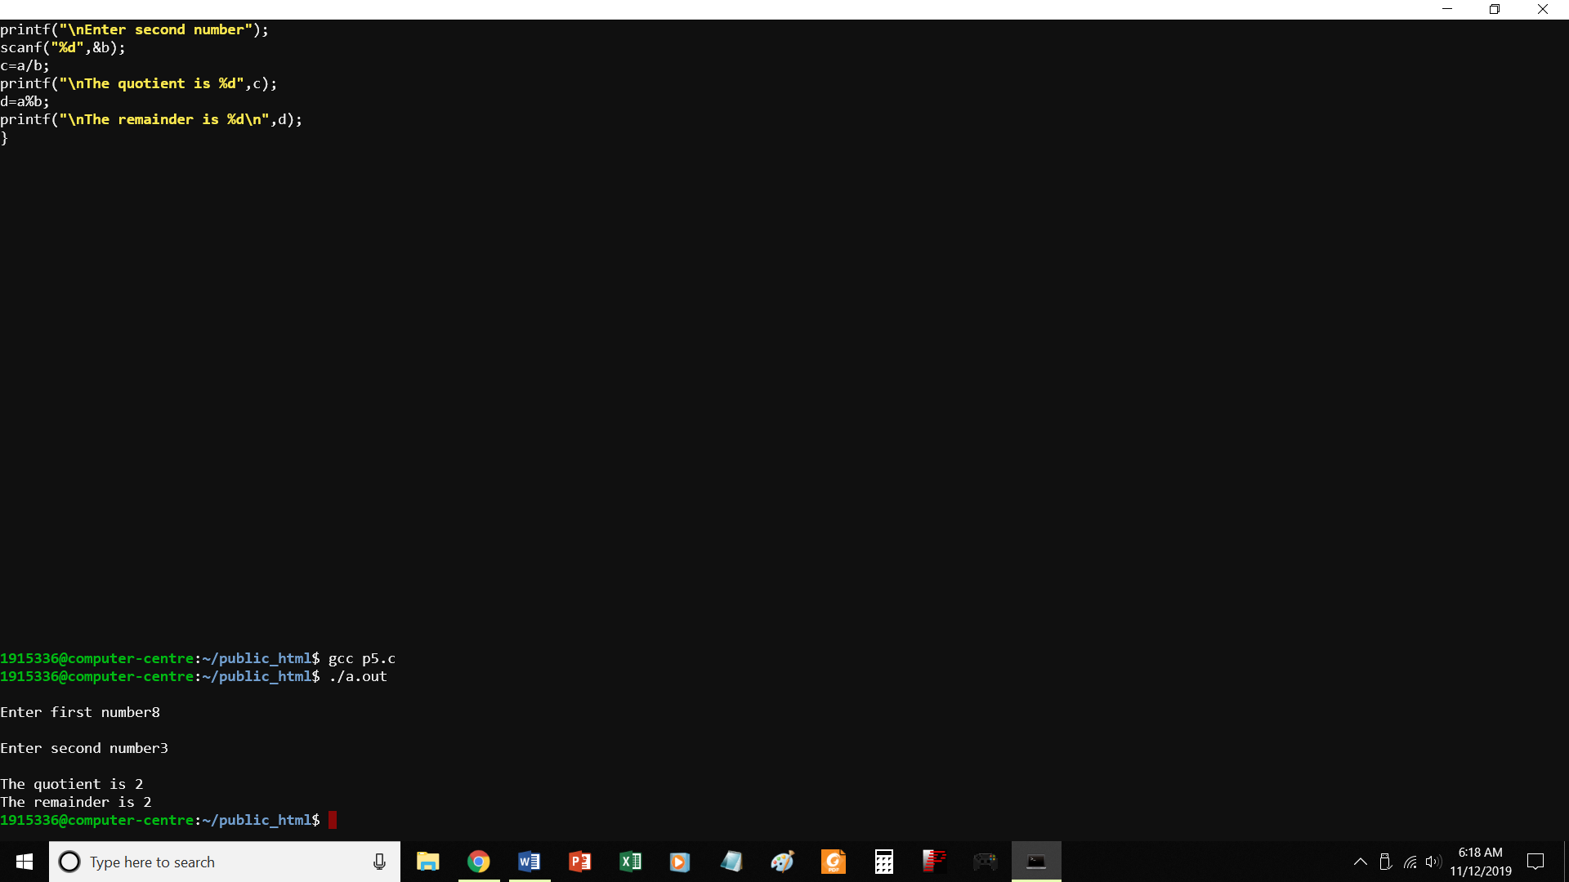

//PROGRAM TO PRINT THE QUOTIENT AND REMAINDER

#include <stdio.h>

void main()

{

int a,b,c,d;

printf("\nEnter first number");

scanf("%d",&a);

printf("\nEnter second number");

scanf("%d",&b);

c=a/b;

printf("\nThe quotient is %d",c);

d=a%b;

printf("\nThe remainder is %d\n",d);

}

P5-1.c

Swap 2 numbers without using third variable

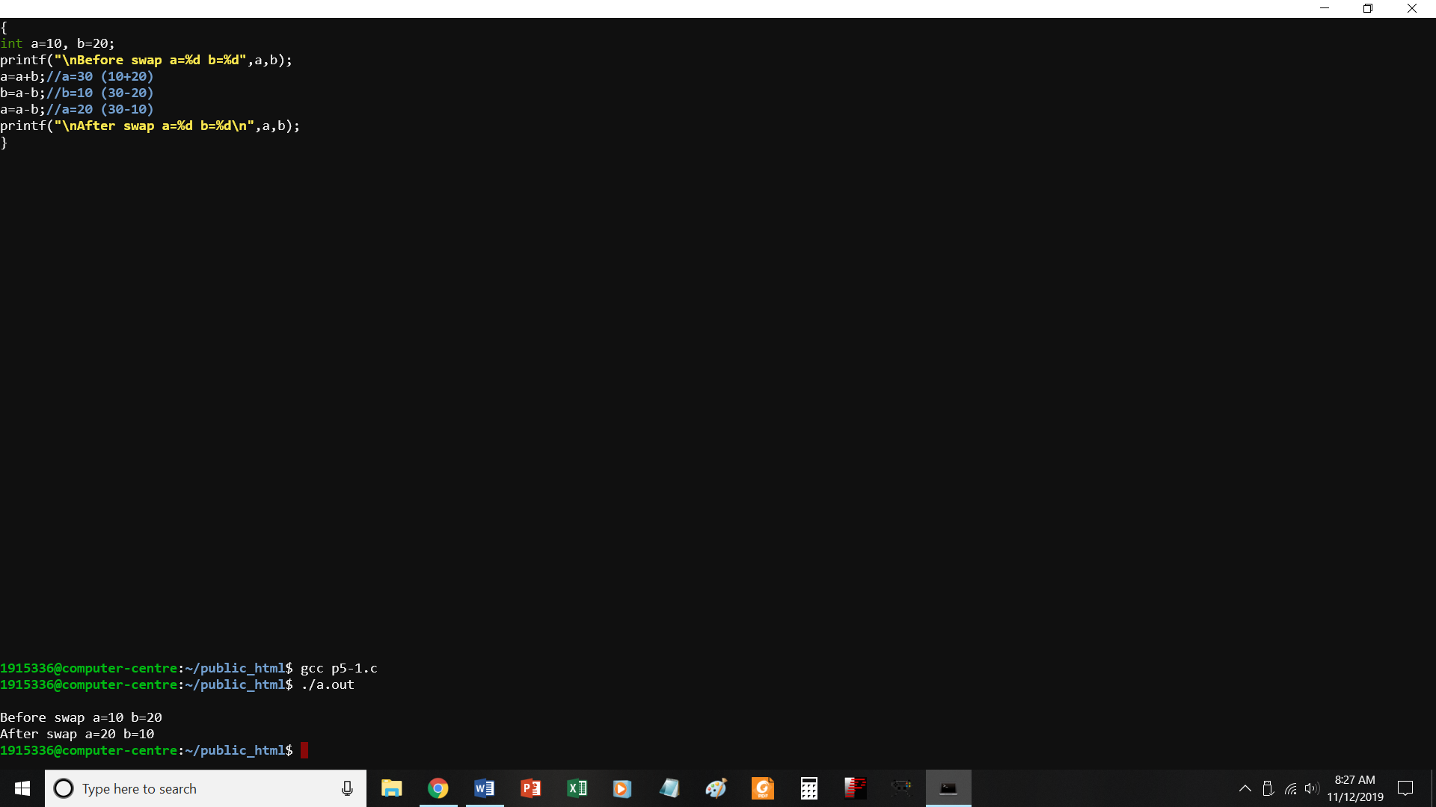

//swap two numbers without using third variable

#include<stdio.h>

int main()

{

int a=10, b=20;

printf("\nBefore swap a=%d b=%d",a,b);

a=a+b;//a=30 (10+20)

b=a-b;//b=10 (30-20)

a=a-b;//a=20 (30-10)

printf("\nAfter swap a=%d b=%d\n",a,b);

}

P6.c to check if a number is odd or even

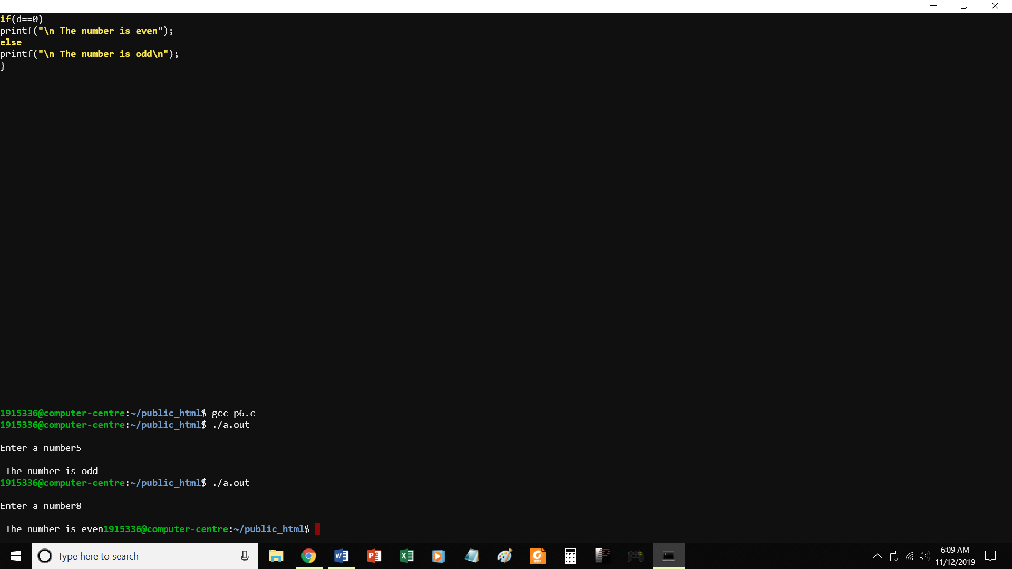

//PROGRAM TO CHECK IF A NUMBER IS EVEN OR ODD

#include <stdio.h>

void main()

{

int a,d;

printf("\nEnter a number");

scanf("%d",&a);

d=a%2;

if(d==0)

printf("\n The number is even");

else

printf("\n The number is odd\n");

}

P7.c find greater of two numbers

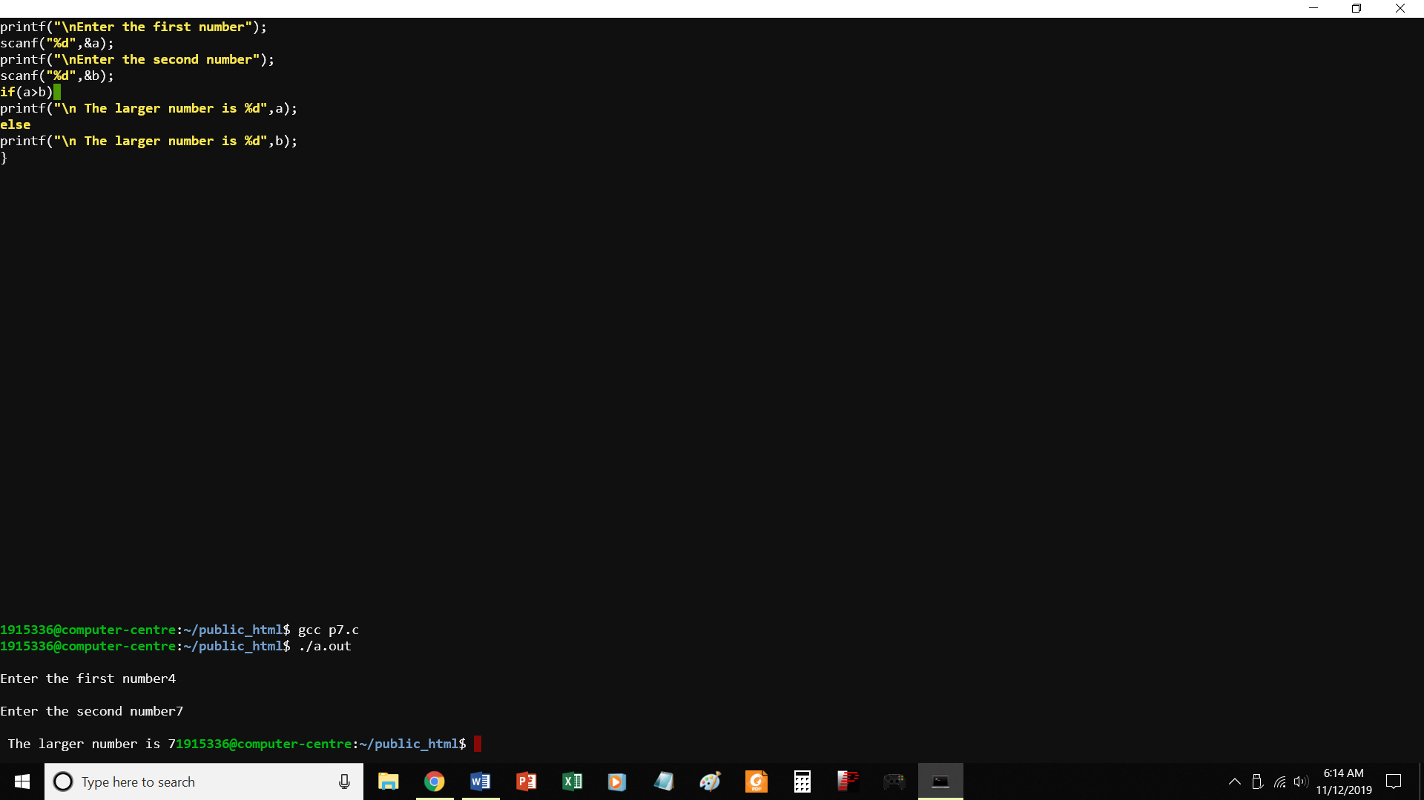

//program to find greater of two numbers

#include <stdio.h>

void main()

{

int a,b,c;

printf("\nEnter the first number");

scanf("%d",&a);

printf("\nEnter the second number");

scanf("%d",&b);

if(a>b)

printf("\n The larger number is %d",a);

else

printf("\n The larger number is %d",b);

}

P8.c Find largest of three numbers

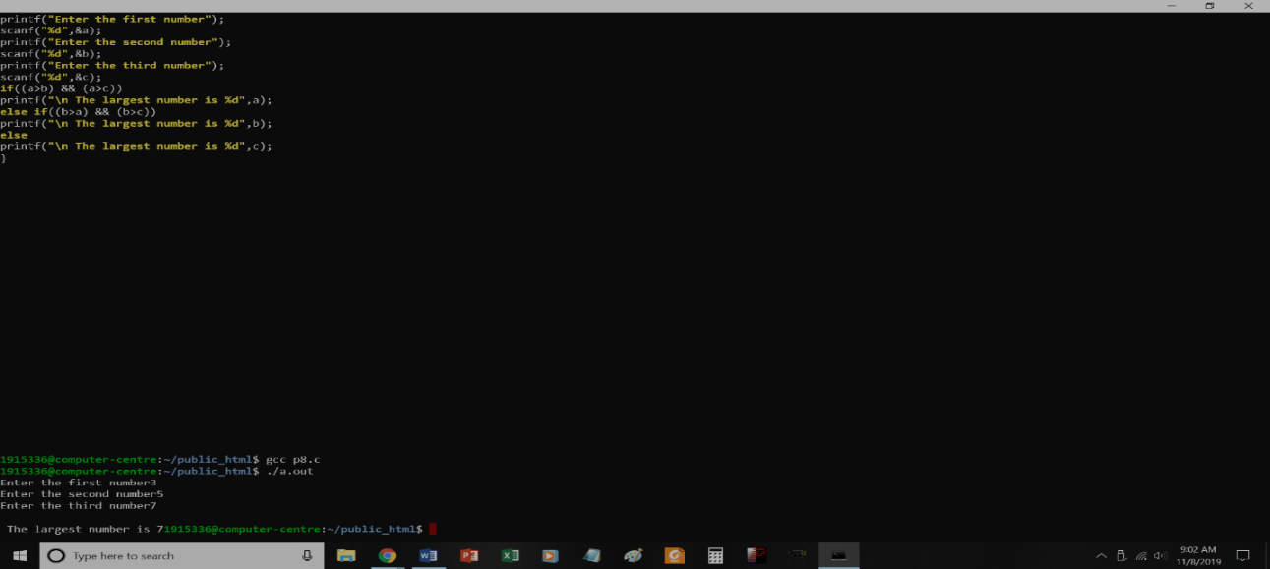

P9.c

Program to print grade of students according to marks entered

#include <stdio.h>

void main()

{

int marks;

printf("Enter the marks of the student out of 100::");

scanf("%d",&marks);

if(marks>=90)

printf("\nO Grade\n");

else if(marks>=75 && marks<90)

printf("\nA Grade\n");

else if(marks>60 && marks <75)

printf("\nB Grade\n");

else if(marks>=50 && marks <60)

printf("\nC Grade\n");

else if (marks>=40 && marks <50)

printf("\nD Grade\n");

else

printf("\nE Grade\n");

}

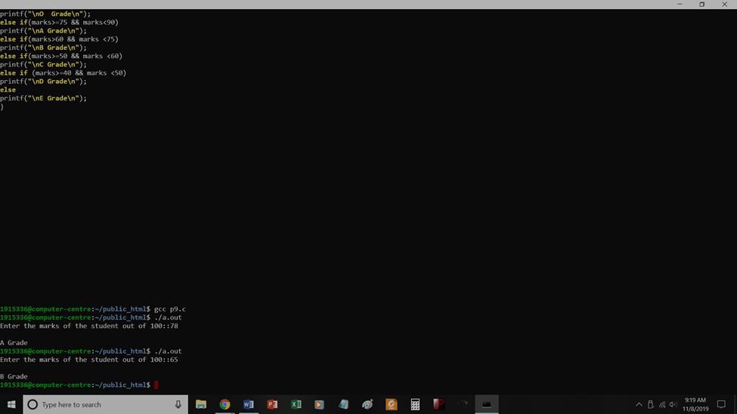

P10.c

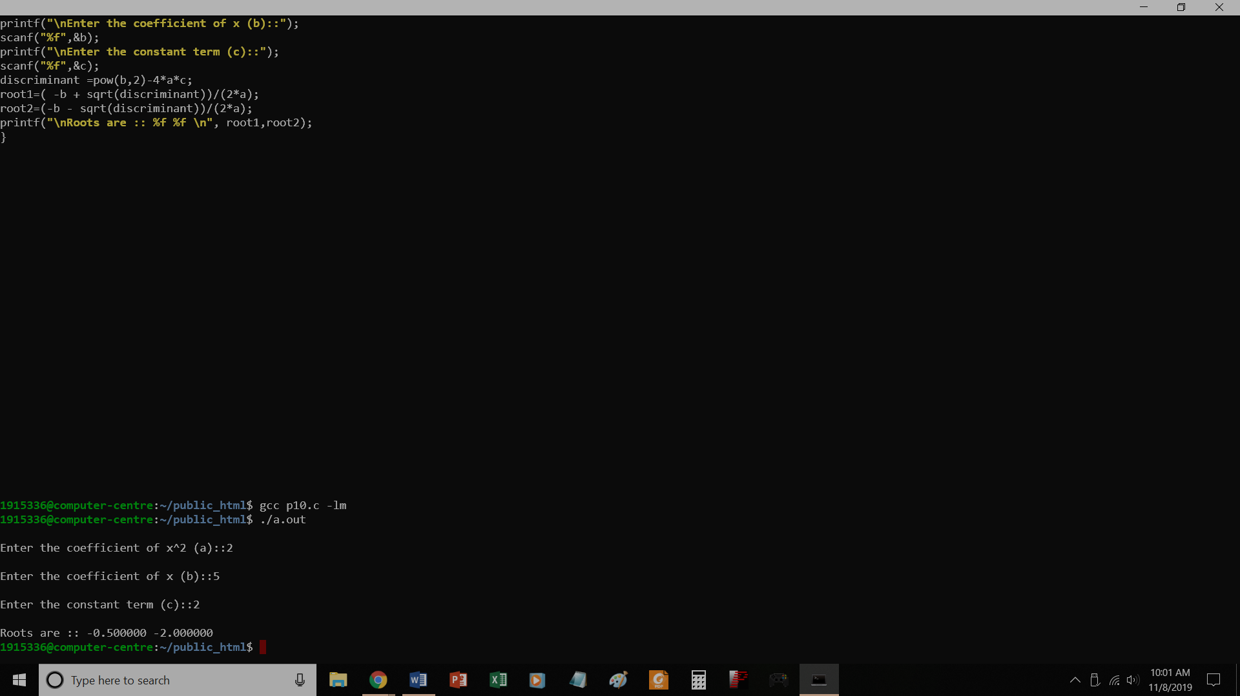

// Find roots of a quadratic equation

#include <stdio.h>

#include<math.h>

void main()

{

float a,b,c,discriminant;

float root1, root2;

printf("\nEnter the coefficient of x^2 (a)::");

scanf("%f",&a);

printf("\nEnter the coefficient of x (b)::");

scanf("%f",&b);

printf("\nEnter the constant term (c)::");

scanf("%f",&c);

discriminant =pow(b,2)-4*a*c;

root1=( -b + sqrt(discriminant))/(2*a);

root2=(-b - sqrt(discriminant))/(2*a);

printf("\nRoots are :: %f %f \n", root1,root2);

}

P11.c

To check whether a year is leap year or not

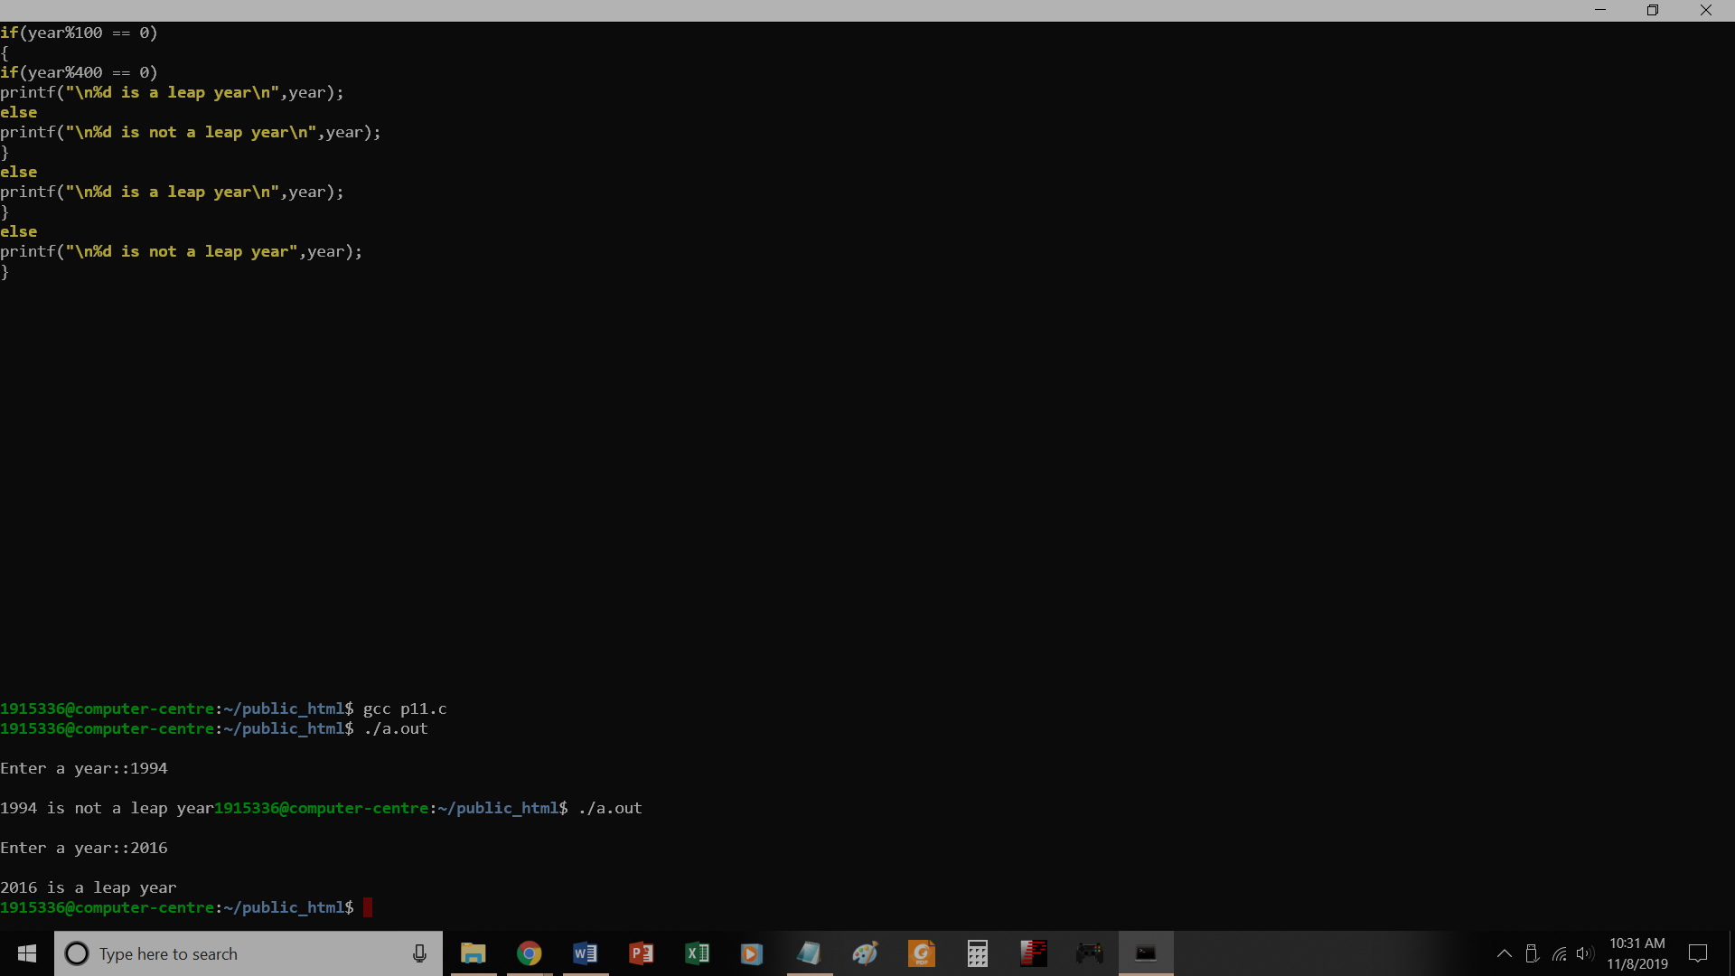

// To check whether a year is leap year or not

#include<stdio.h>

void main()

{

int year;

printf("\nEnter a year::");

scanf("%d",&year);

if(year%4==0)

{

if(year%100 == 0)

{

if(year%400 == 0)

printf("\n%d is a leap year\n",year);

else

printf("\n%d is not a leap year\n",year);

}

else

printf("\n%d is a leap year\n",year);

}

else

printf("\n%d is not a leap year",year);

}

P12.c

Program to generate multiple of 5

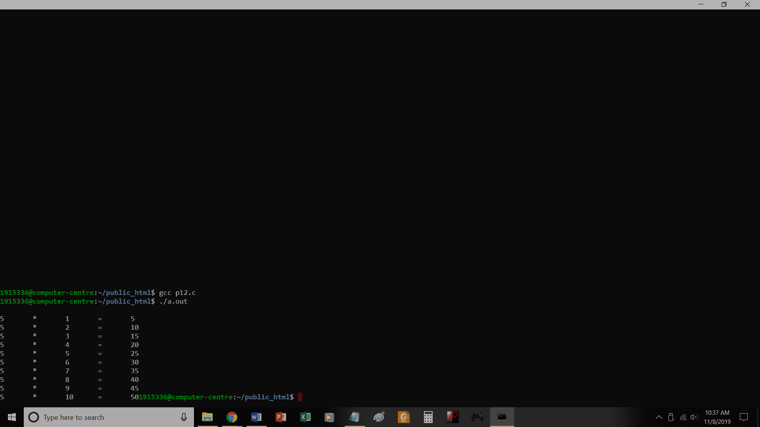

// Program to generate multiple of 5

#include<stdio.h>

void main()

{

int i;

for (i=1;i <=10; i++)

printf("\n5\t*\t%d\t=\t%d",i,5*i);

}

P13.c

To make simple calculator using switch

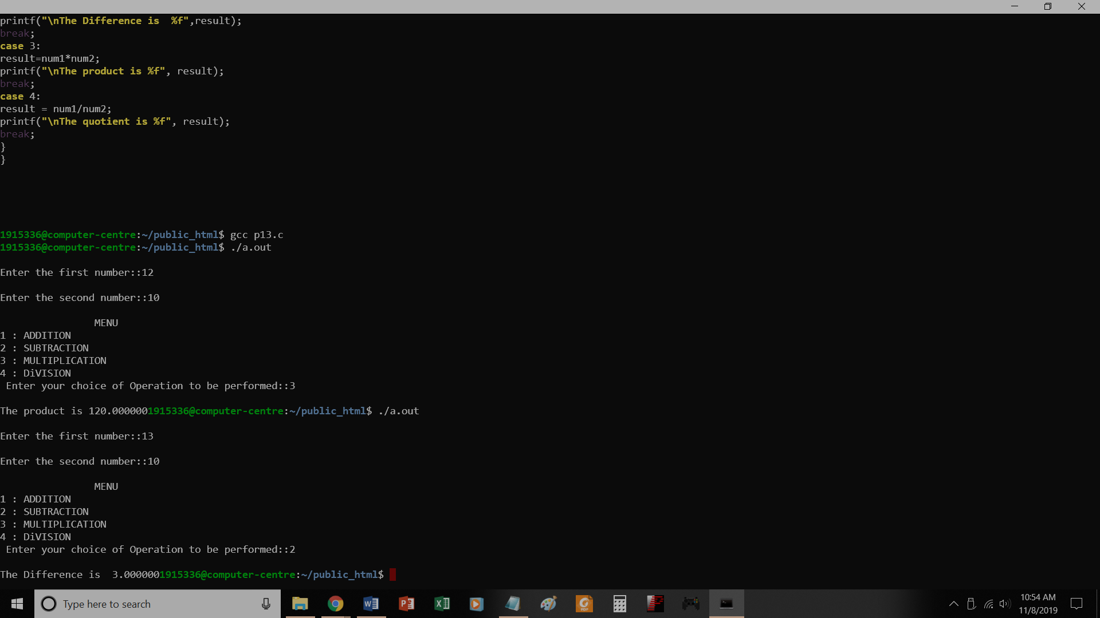

// To make simple calculator using switch

#include<stdio.h>

void main()

{

int num1, num2, choice;

float result;

printf("\nEnter the first number::");

scanf("%d",&num1);

printf("\nEnter the second number::");

scanf("%d",&num2);

printf("\n\t\tMENU");

printf("\n1 : ADDITION");

printf("\n2 : SUBTRACTION");

printf("\n3 : MULTIPLICATION");

printf("\n4 : DiVISION");

printf("\n Enter your choice of Operation to be performed::");

scanf("%d",&choice);

switch(choice)

{

case 1:

result = num1+num2;

printf("\nThe Sum is %f", result);

break;

case 2:

result=num1-num2;

printf("\nThe Difference is %f",result);

break;

case 3:

result=num1*num2;

printf("\nThe product is %f", result);

break;

case 4:

result = num1/num2;

printf("\nThe quotient is %f", result);

break;

}

}

P14.c

Calculate reverse of a number

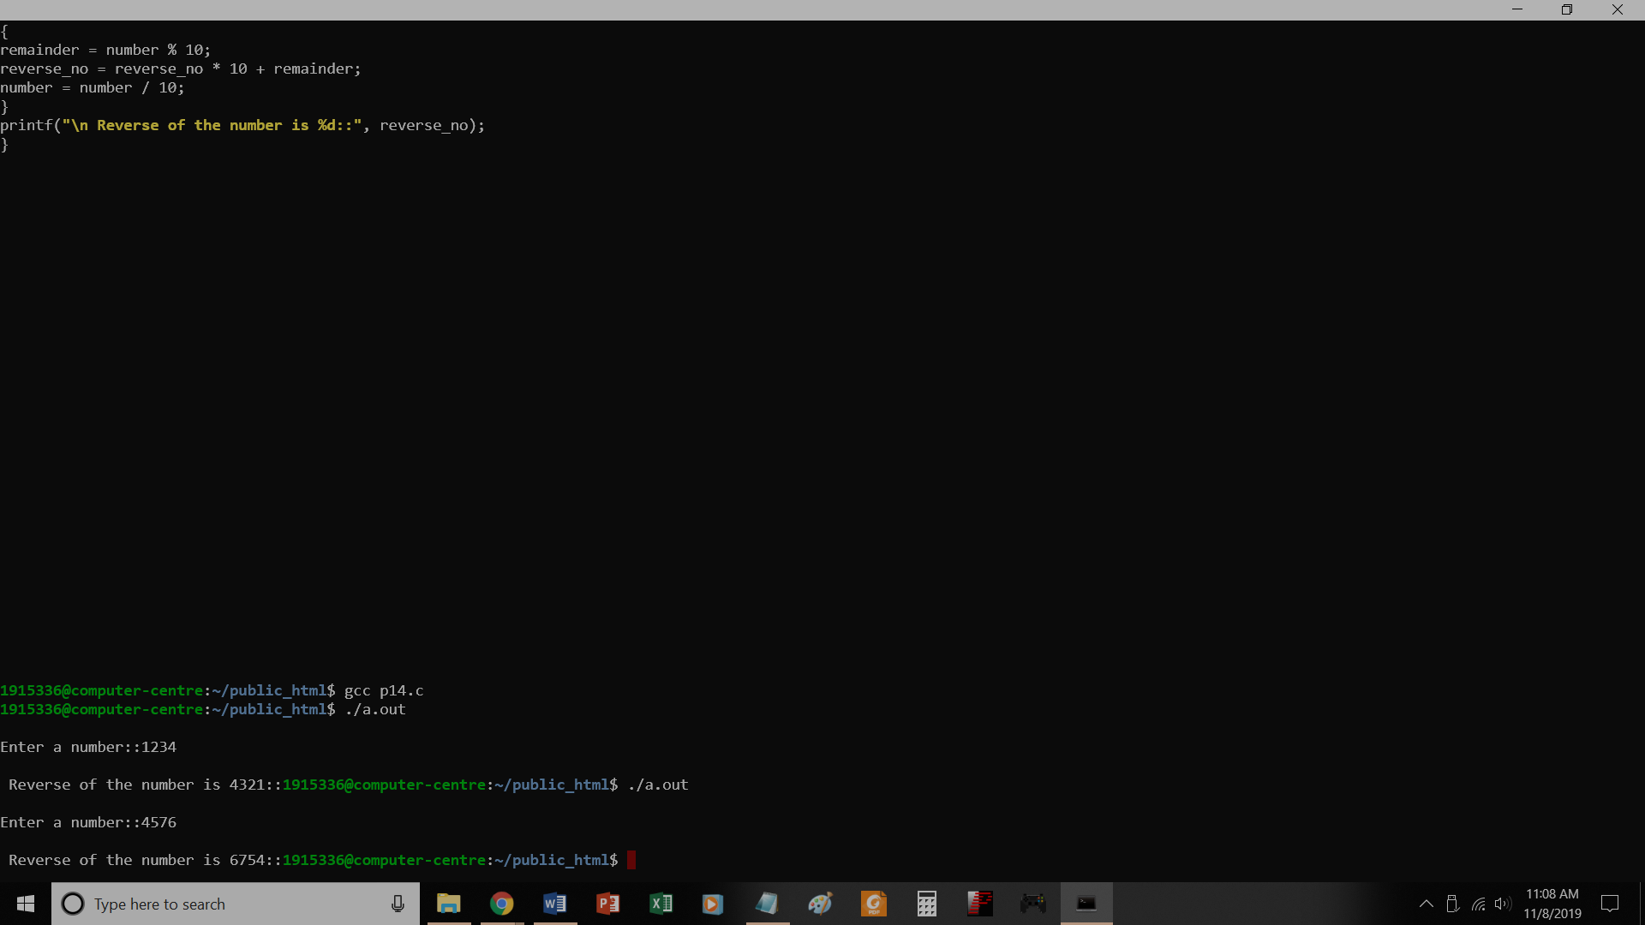

// Calculate reverse of a number

#include<stdio.h>

void main()

{

int number, remainder, reverse_no=0;

printf("\nEnter a number::");

scanf("%d",&number);

while(number != 0)

{

remainder = number % 10;

reverse_no = reverse_no * 10 + remainder;

number = number / 10;

}

printf("\n Reverse of the number is %d::", reverse_no);

}

P15.c

Check whether a number is palindrome

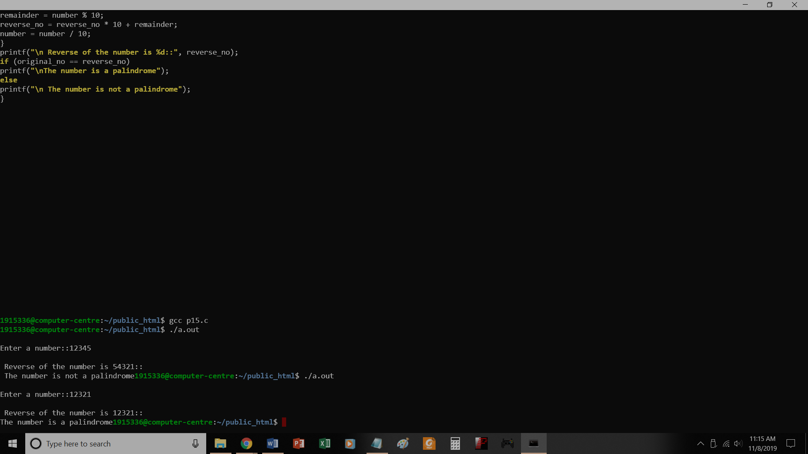

// Check whether a number is palindrome

#include<stdio.h>

void main()

{

int number, remainder, original_no, reverse_no=0;

printf("\nEnter a number::");

scanf("%d",&number);

original_no=number;

while(number != 0)

{

remainder = number % 10;

reverse_no = reverse_no * 10 + remainder;

number = number / 10;

}

printf("\n Reverse of the number is %d::", reverse_no);

if (original_no == reverse_no)

printf("\nThe number is a palindrome");

else

printf("\n The number is not a palindrome");

}

P16.c

Prime or not

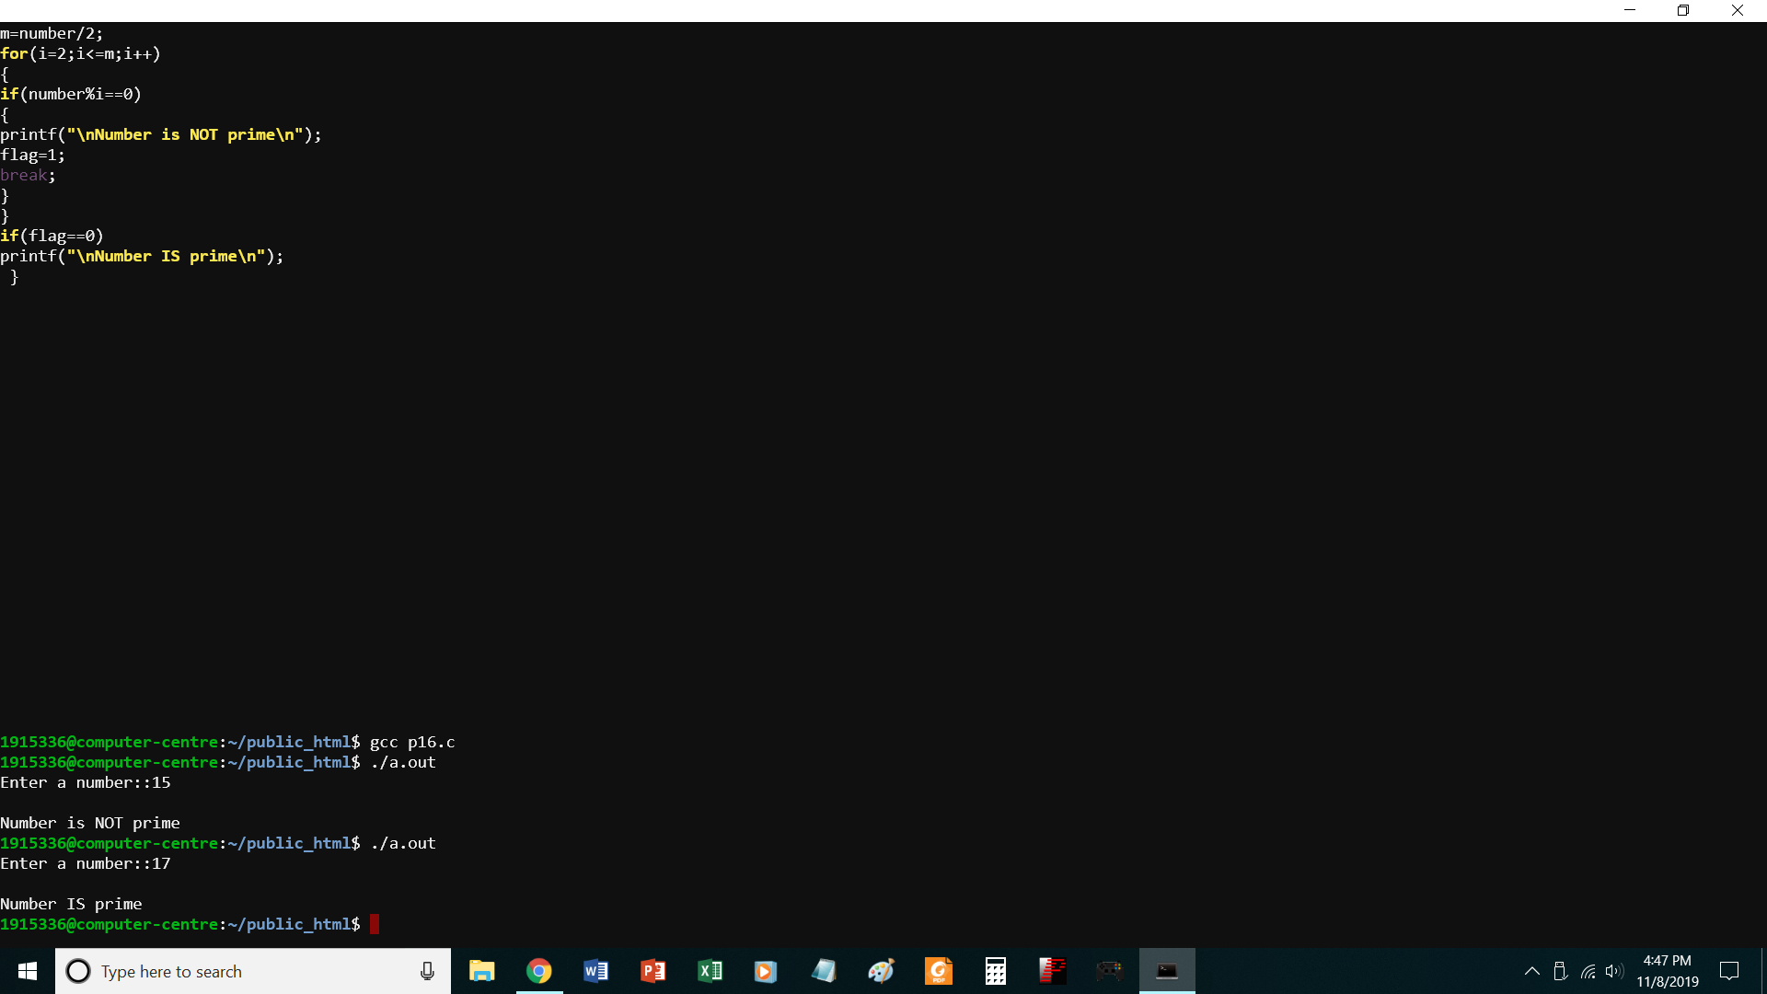

//PROGRAM TO CHECK WHETHER A NO. IS PRIME OR NOT

#include<stdio.h>

void main()

{

int number,i,m=0,flag=0;

printf("Enter a number::");

scanf("%d",&number);

m=number/2;

for(i=2;i<=m;i++)

{

if(number%i==0)

{

printf("\nNumber is NOT prime\n");

flag=1;

break;

}

}

if(flag==0)

printf("\nNumber IS prime\n");

}

P17.c

Prime numbers 1 to 100

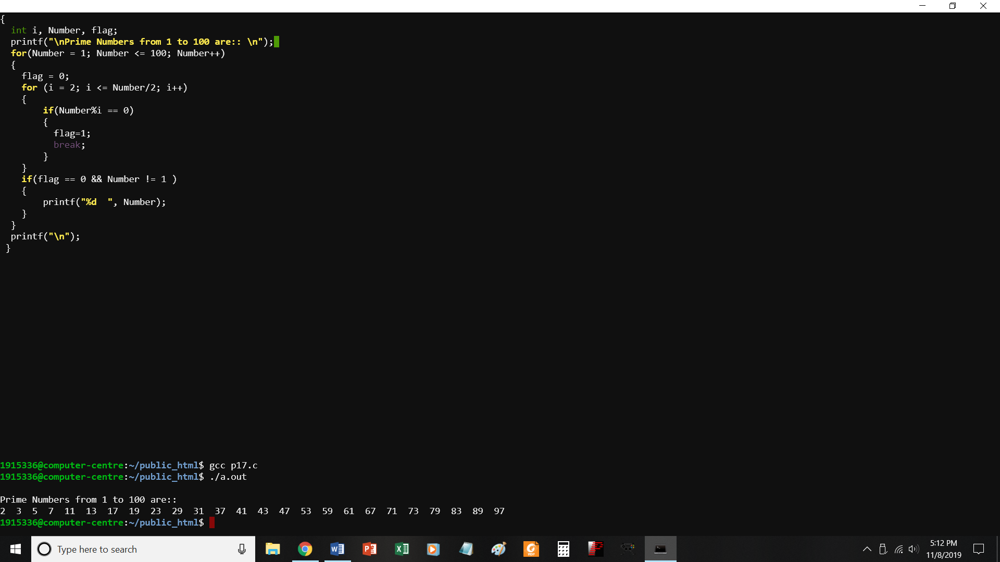

//PROGRAM TO PRINT PRIME NUMBERS FROM 1 TO 100

#include <stdio.h>

void main()

{

int i, Number, flag;

printf("\nPrime Numbers from 1 to 100 are:: \n");

for(Number = 1; Number <= 100; Number++)

{

flag = 0;

for (i = 2; i <= Number/2; i++)

{

if(Number%i == 0)

{

flag=1;

break;

}

}

if(flag == 0 && Number != 1 )

{

printf("%d ", Number);

}

}

printf("\n");

}

P18.c

To check whether a number is Armstrong or not

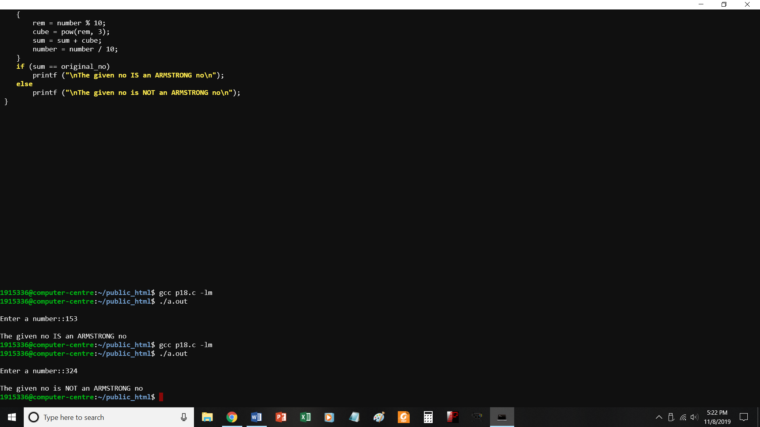

//PROGRAM TO CHECK WHETHER A NO. IS AN ARMSTRONG NUMBER OR NOT

#include<stdio.h> #include <math.h>

void main()

{

int number, sum = 0, rem = 0, cube = 0, original_no;

printf ("\nEnter a number::");

{

rem = number % 10;

cube = pow(rem, 3);

sum = sum + cube;

number = number / 10;

}

if (sum == original_no)

printf ("\nThe given no IS an ARMSTRONG no\n");

else

printf ("\nThe given no is NOT an ARMSTRONG no\n");

}

P19_1.c

Program to generate pattern

1

1 2

1 2 3

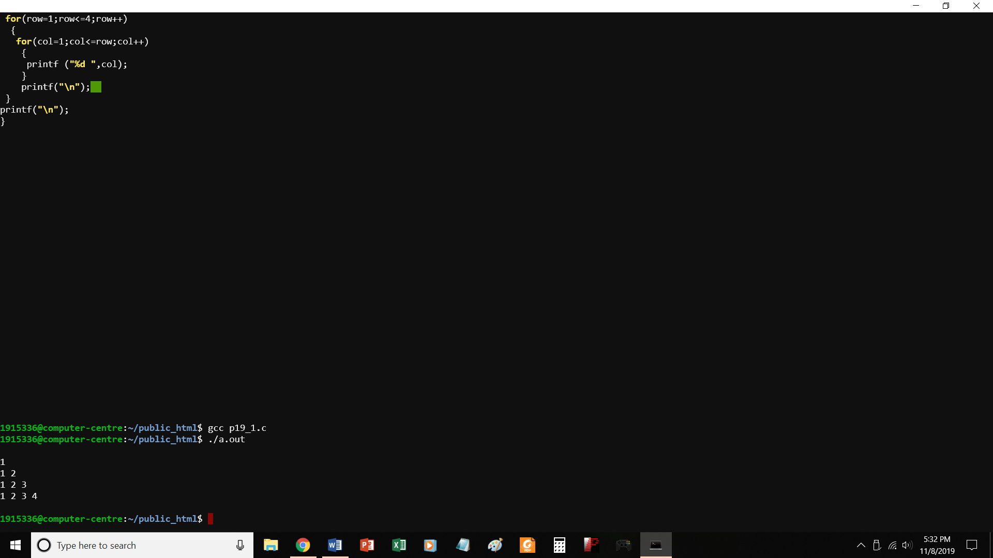

//PROGRAM TO PRINT A PATTERN

#include<stdio.h>

void main()

{

int row, col;

printf("\n");

for(row=1;row<=4;row++)

{

for(col=1;col<=row;col++)

{

printf ("%d ",col);

}

printf("\n");

}

printf("\n");

}

P19_2.C

TO PRINT A PATTERN

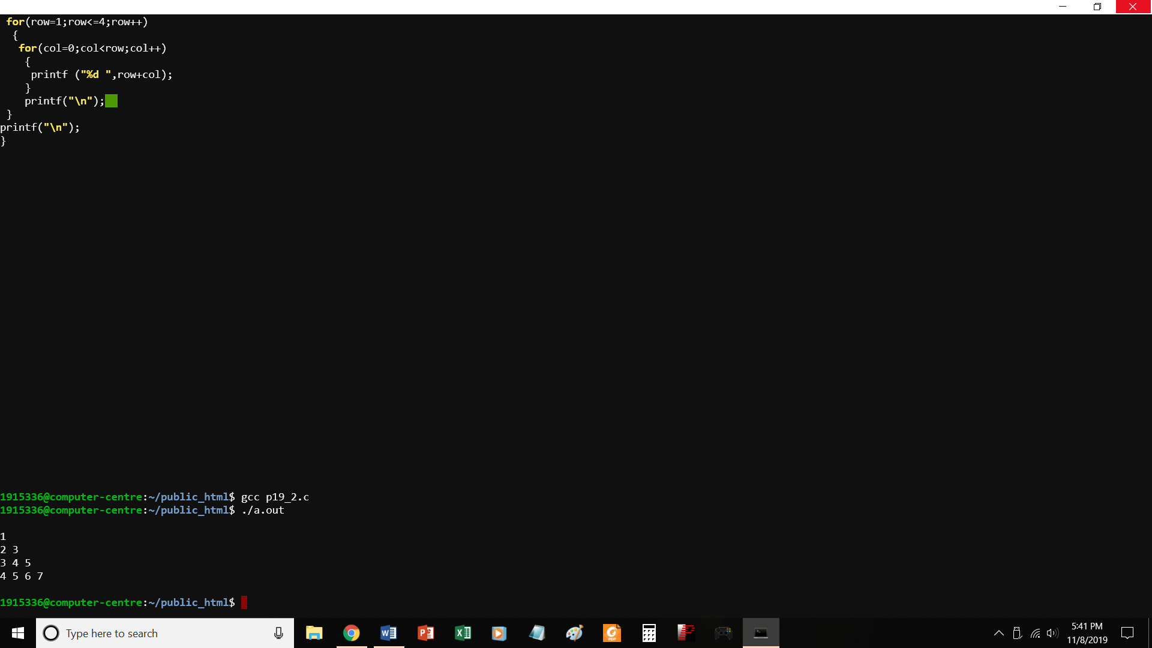

//PROGRAM TO PRINT A PATTERN -2

#include<stdio.h>

void main()

{

int row, col;

printf("\n");

for(row=1;row<=4;row++)

{

for(col=0;col<row;col++)

{

printf ("%d ",row+col);

}

printf("\n");

}

printf("\n");

}

P19_3.c

Print a pattern

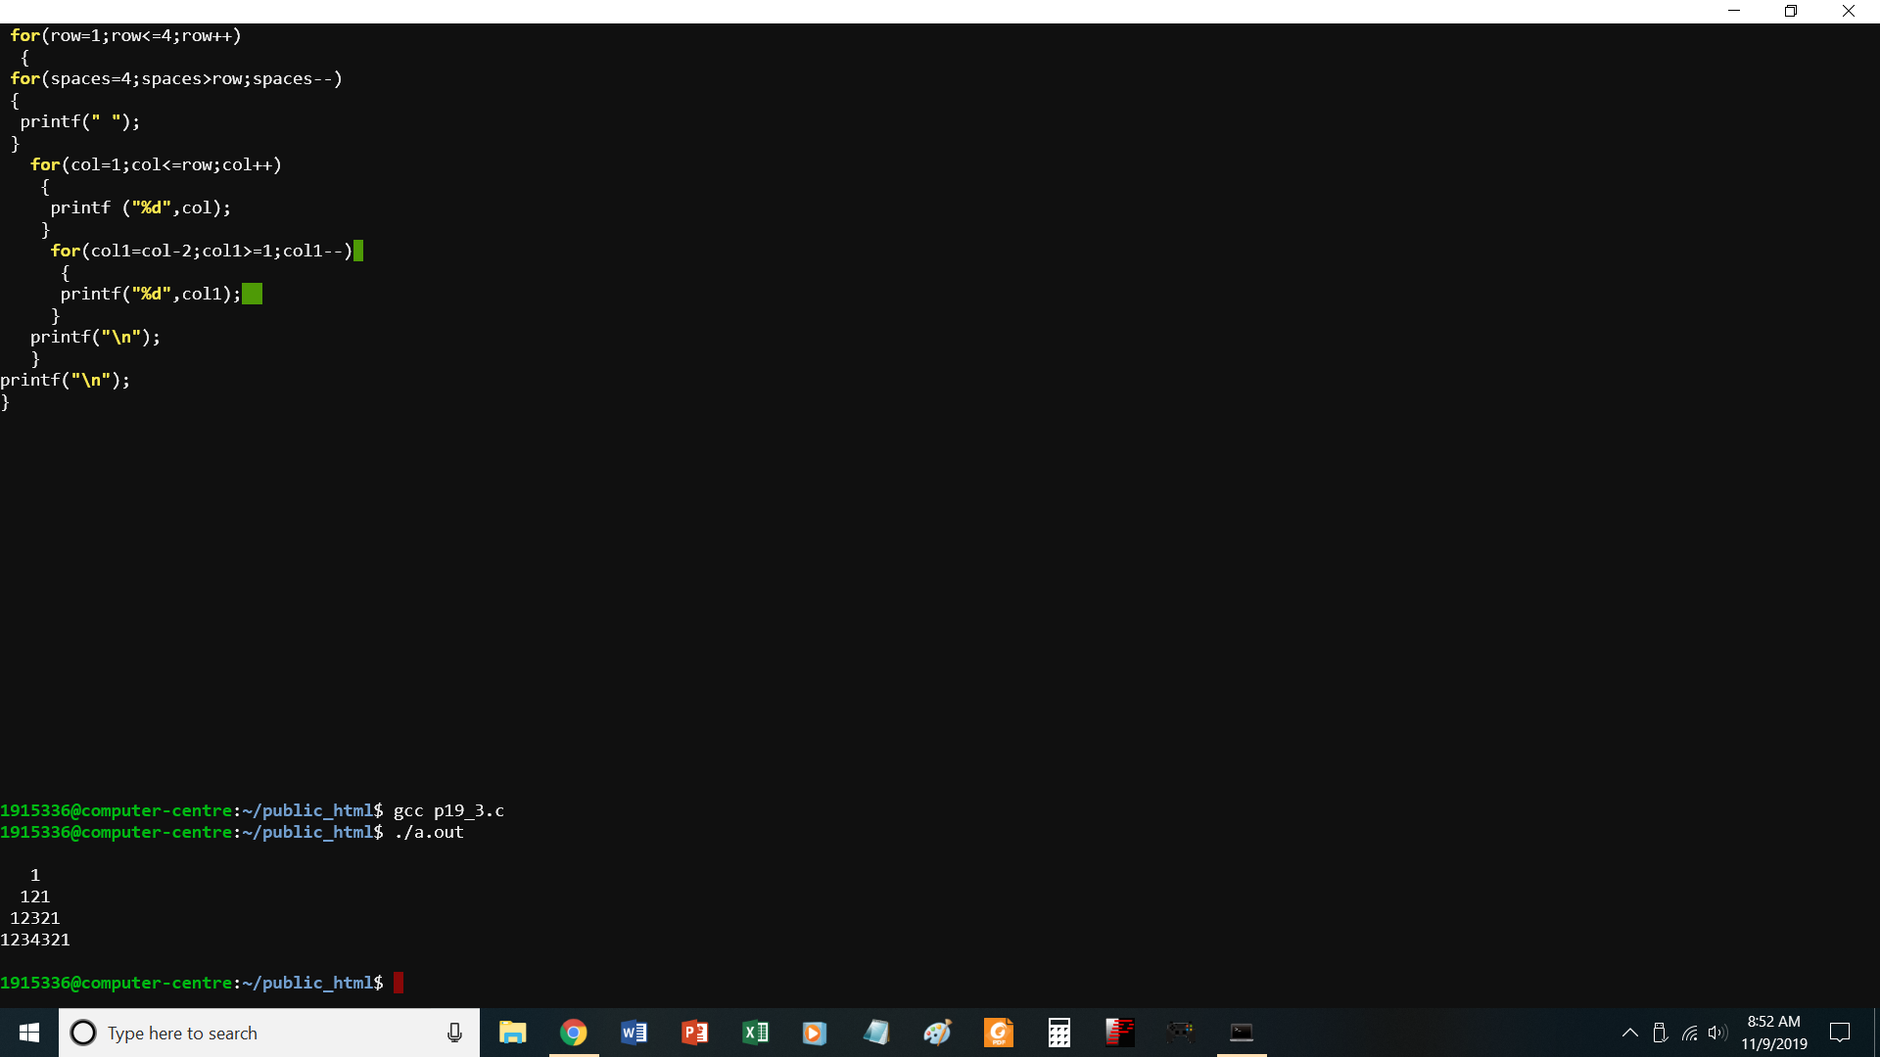

//PROGRAM TO PRINT A PATTERN -3

#include<stdio.h>

void main()

{

int row, col,col1,spaces;

printf("\n");

for(row=1;row<=4;row++)

{

for(spaces=4;spaces>row;spaces--)

{

printf(" ");

}

for(col=1;col<=row;col++)

{

printf ("%d",col);

}

for(col1=col-2;col1>=1;col1--)

{

printf("%d",col1);

}

printf("\n");

}

printf("\n");

}

P20.c

Find largest element from 1-D array

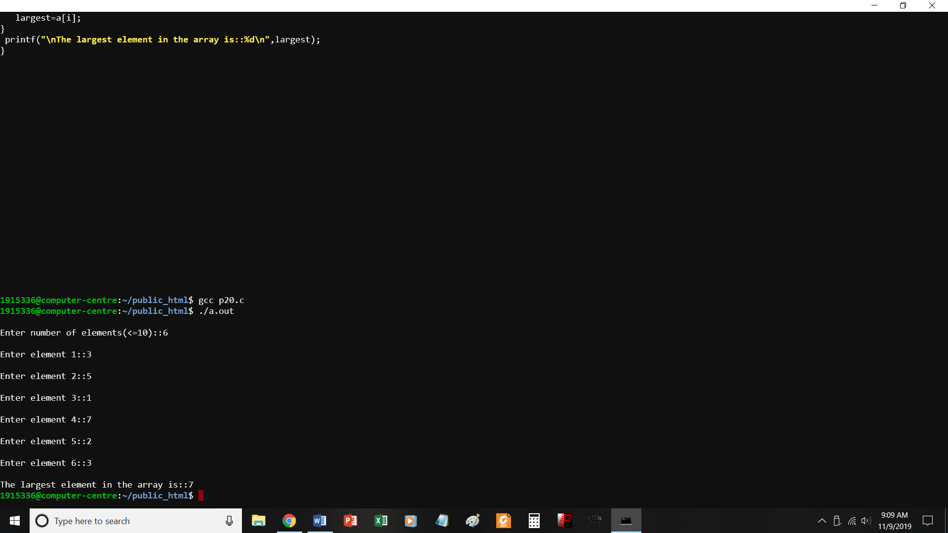

//PROGRAM TO FIND LARGEST ELEMENT FROM 1-D ARRAY

#include<stdio.h>

void main()

{

int a[10],i, largest,n;

printf("\nEnter number of elements(<=10)::");

scanf("%d",&n);

for(i=0;i<=n-1;i++)

{

printf("\nEnter element %d::",i+1);

scanf("%d",&a[i]);

}

largest=a[0];

for(i=1;i<=n-1;i++)

{

if(a[i]>largest)

largest=a[i];

}

printf("\nThe largest element in the array is::%d\n",largest);

}

P21.c

Find sum of n elements of array

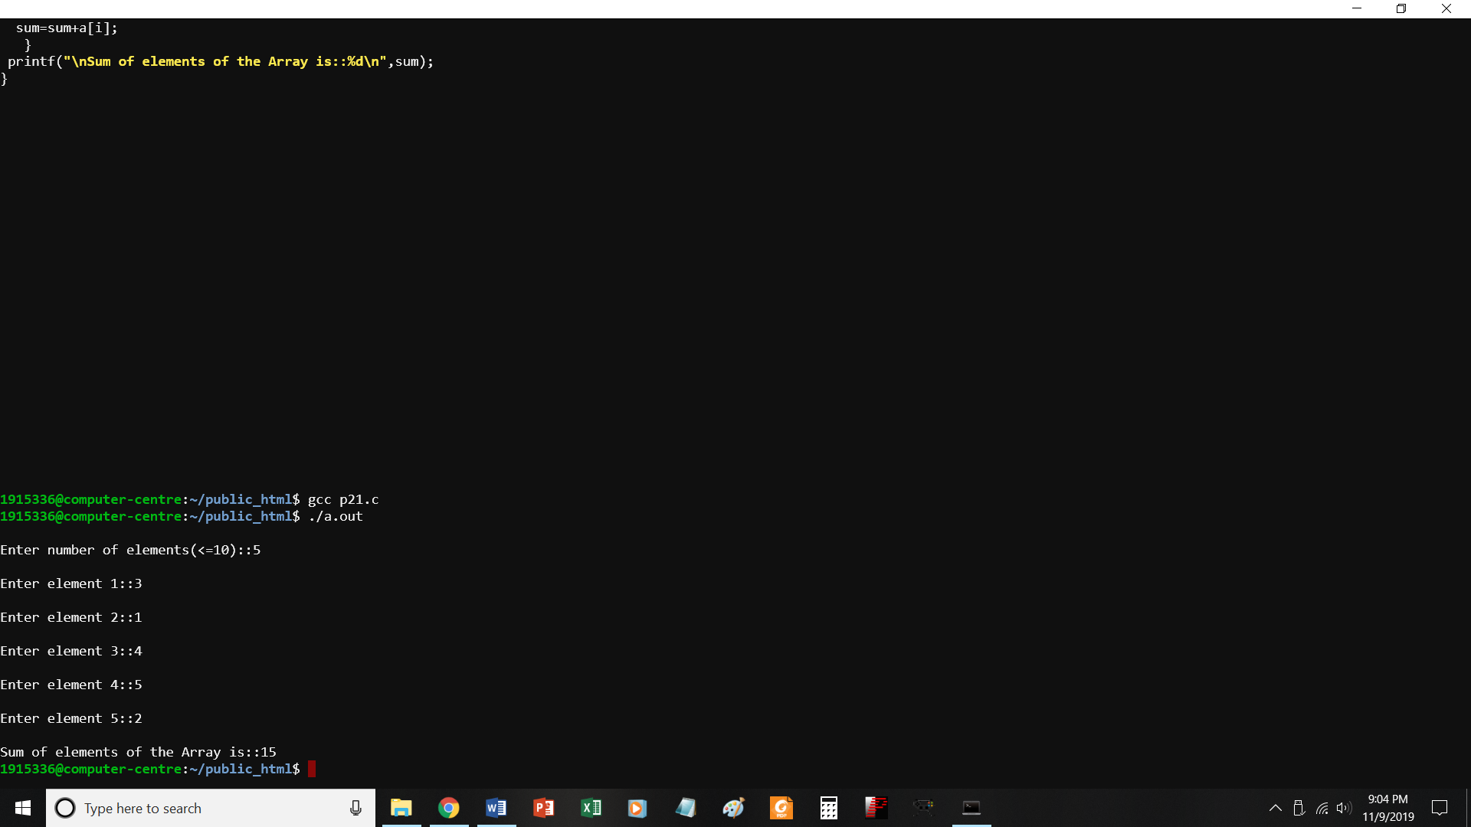

//PROGRAM TO FIND SUM OF N ELEMENTS OF AN ARRAY

#include<stdio.h>

void main()

{

int a[10],i, sum=0,n;

printf("\nEnter number of elements(<=10)::");

scanf("%d",&n);

for(i=0;i<=n-1;i++)

{

printf("\nEnter element %d::",i+1);

scanf("%d",&a[i]);

}

for(i=0;i<=n-1;i++)

{

sum=sum+a[i];

}

printf("\nSum of elements of the Array is::%d\n",sum);

}

P22.c

To add 2 matrices

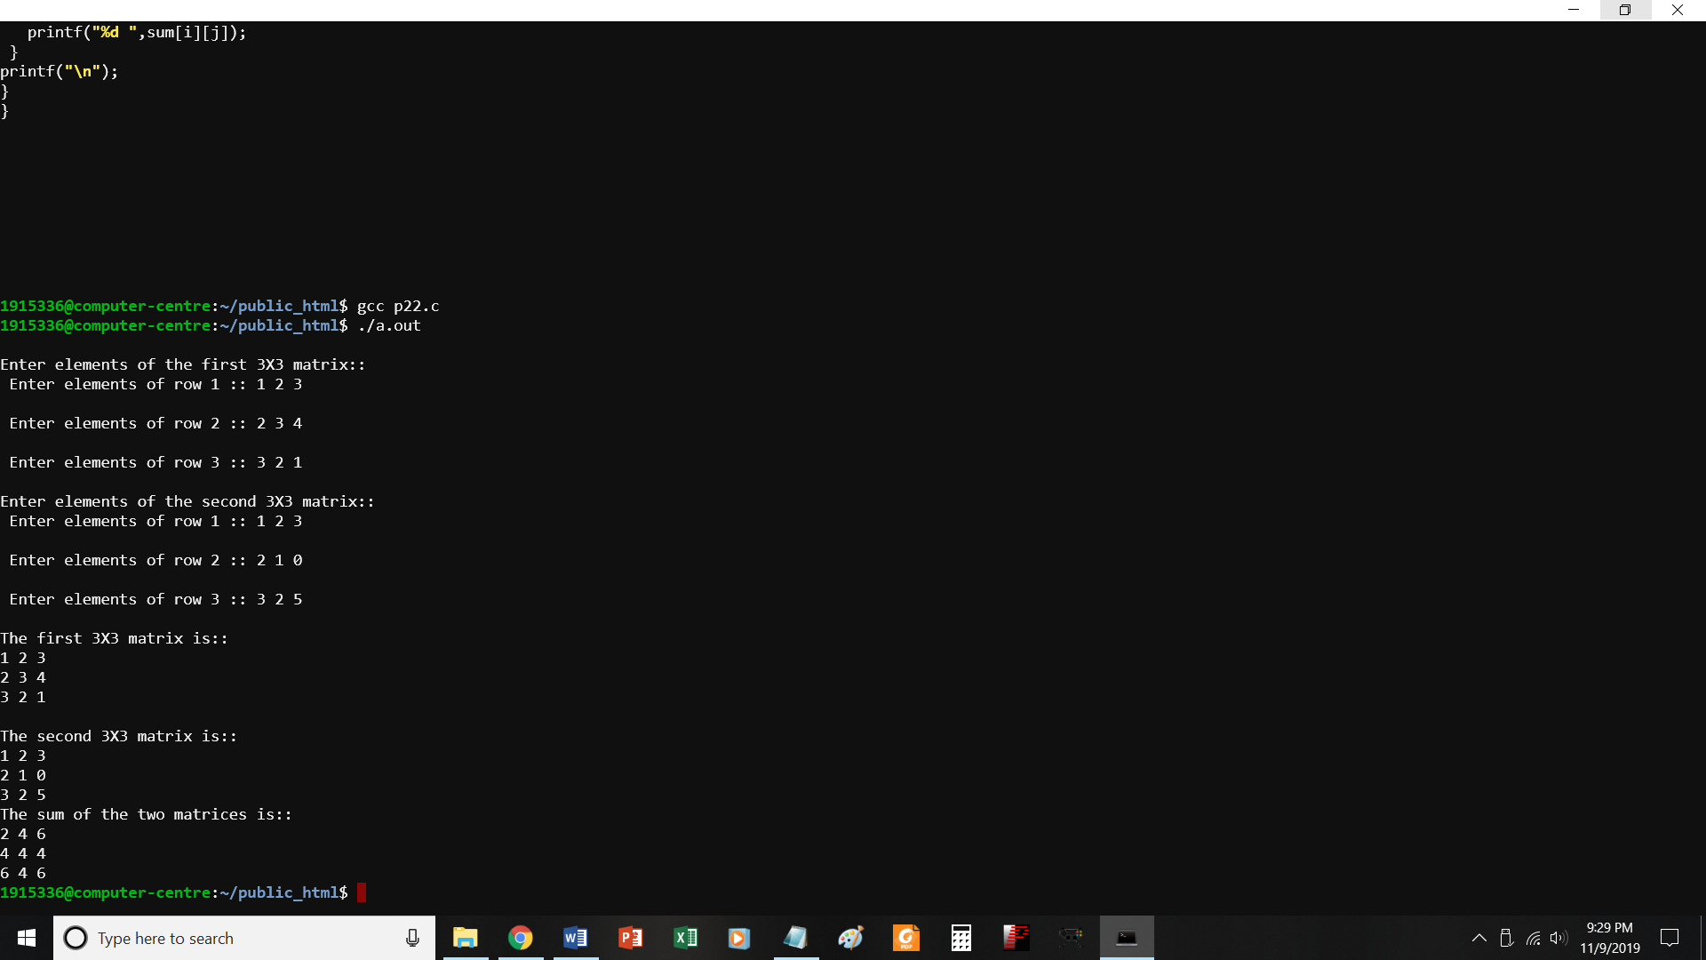

//PROGRAM TO FIND SUM OF TWO MATRICES

#include<stdio.h>

void main()

{

int a[3][3],b[3][3], sum[3][3],i,j;

printf("\nEnter elements of the first 3X3 matrix::");

for(i=0;i<=2;i++)

{

printf("\n Enter elements of row %d :: ", i+1);

for(j=0;j<=2;j++)

{

scanf("%d",&a[i][j]);

}

}

printf("\nEnter elements of the second 3X3 matrix::");

for(i=0;i<=2;i++)

{

printf("\n Enter elements of row %d :: ", i+1);

for(j=0;j<=2;j++)

{

scanf("%d",&b[i][j]);

}

}

printf("\nThe first 3X3 matrix is::\n");

for(i=0;i<=2;i++)

{

for(j=0;j<=2;j++)

{

printf("%d ",a[i][j]);

}

printf("\n");

}

printf("\nThe second 3X3 matrix is::\n");

for(i=0;i<=2;i++)

{

for(j=0;j<=2;j++)

{

printf("%d ",b[i][j]);

}

P23.c

Multiply 2 matrices

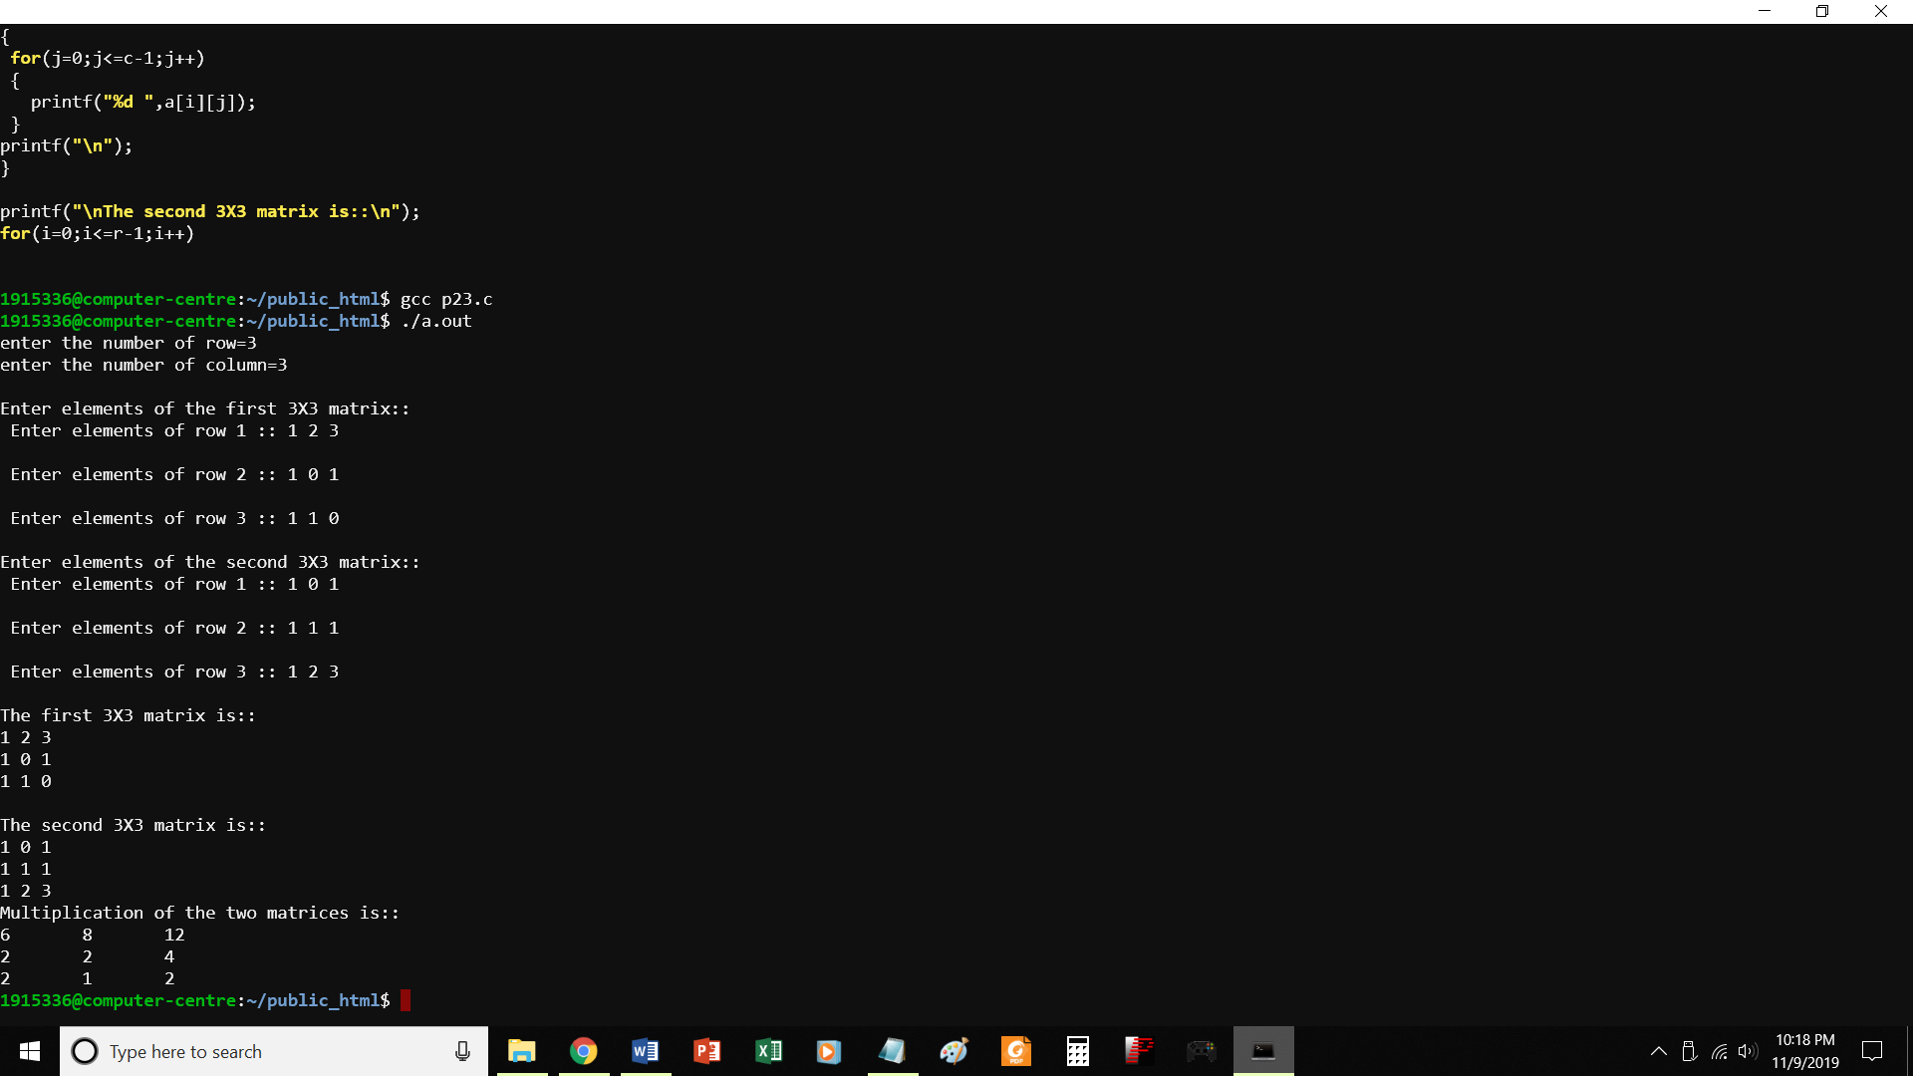

//PROGRAM TO FIND PRODUCT OF TWO MATRICES

#include<stdio.h>

#include<stdlib.h>

int main()

{

int a[10][10],b[10][10],mul[10][10],r,c,i,j,k;

printf("enter the number of row=");

scanf("%d",&r);

printf("enter the number of column=");

scanf("%d",&c);

printf("\nEnter elements of the first 3X3 matrix::");

for(i=0;i<=r-1;i++)

{

printf("\n Enter elements of row %d :: ", i+1);

for(j=0;j<=c-1;j++)

{

scanf("%d",&a[i][j]);

}

}

printf("\nEnter elements of the second 3X3 matrix::");

for(i=0;i<=r-1;i++)

{

printf("\n Enter elements of row %d :: ", i+1);

for(j=0;j<=c-1;j++)

{

scanf("%d",&b[i][j]);

}

}

printf("\nThe first 3X3 matrix is::\n");

for(i=0;i<=r-1;i++)

{

for(j=0;j<=c-1;j++)

{

printf("%d ",a[i][j]);

}

printf("\n");

}

printf("\nThe second 3X3 matrix is::\n");

for(i=0;i<=r-1;i++)

{

for(j=0;j<=c-1;j++)

{

printf("%d ",b[i][j]);

}

printf("\n");

}

printf("Multiplication of the two matrices is::\n");

for(i=0;i<r;i++)

{

for(j=0;j<c;j++)

{

mul[i][j]=0;

for(k=0;k<c;k++)

{

mul[i][j]+=a[i][k]*b[k][j];

}

}

}

//for printing result

for(i=0;i<r;i++)

{

for(j=0;j<c;j++)

{

printf("%d\t",mul[i][j]);

}

printf("\n");

}

}

P24.c

Tp find whether a string is palindrome

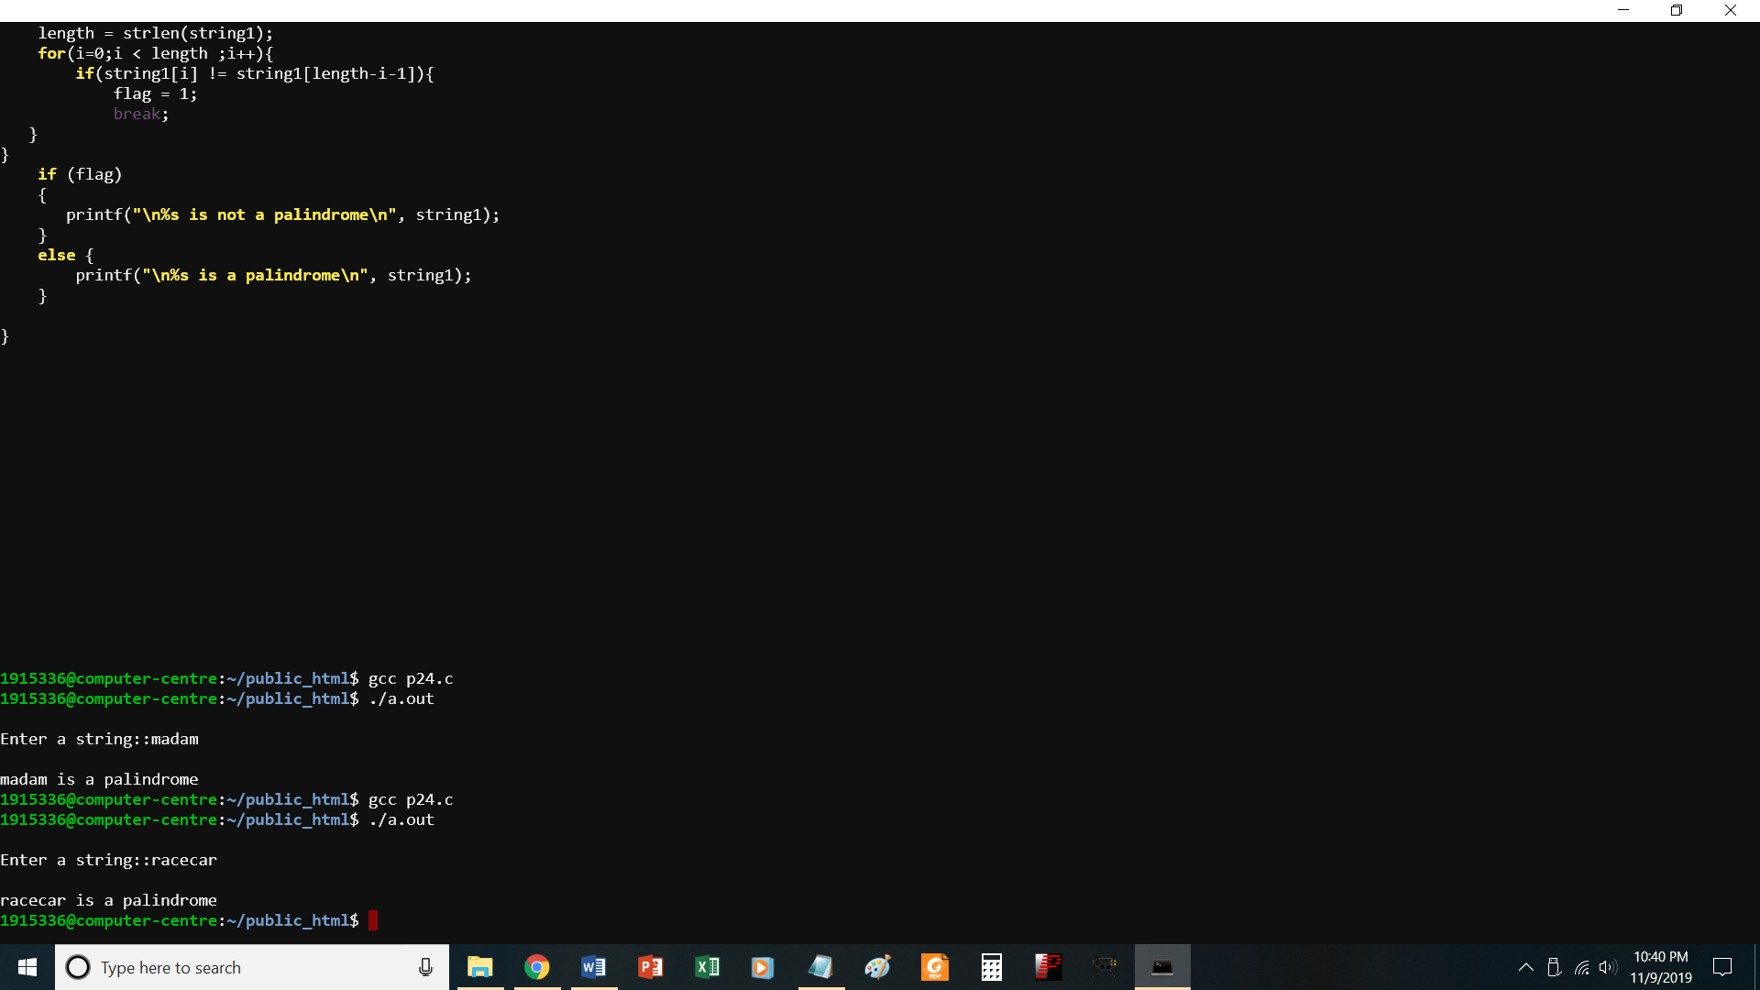

//PROGRAM TO CHECK WHETHER A STRING IS PALINDROME

#include<stdio.h>

#include<string.h>

void main()

{

char string1[20];

int i, length;

int flag = 0;

printf("\nEnter a string::");

scanf("%s", string1);

length = strlen(string1);

for(i=0;i < length ;i++){

if(string1[i] != string1[length-i-1]){

flag = 1;

break;

}

}

if (flag)

{

printf("\n%s is not a palindrome\n", string1);

}

else {

printf("\n%s is a palindrome\n", string1);

}

}

P25.c

To perform basic string operations

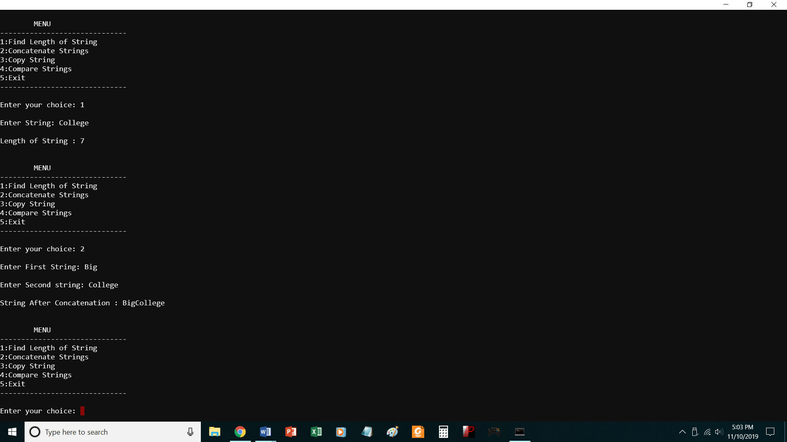

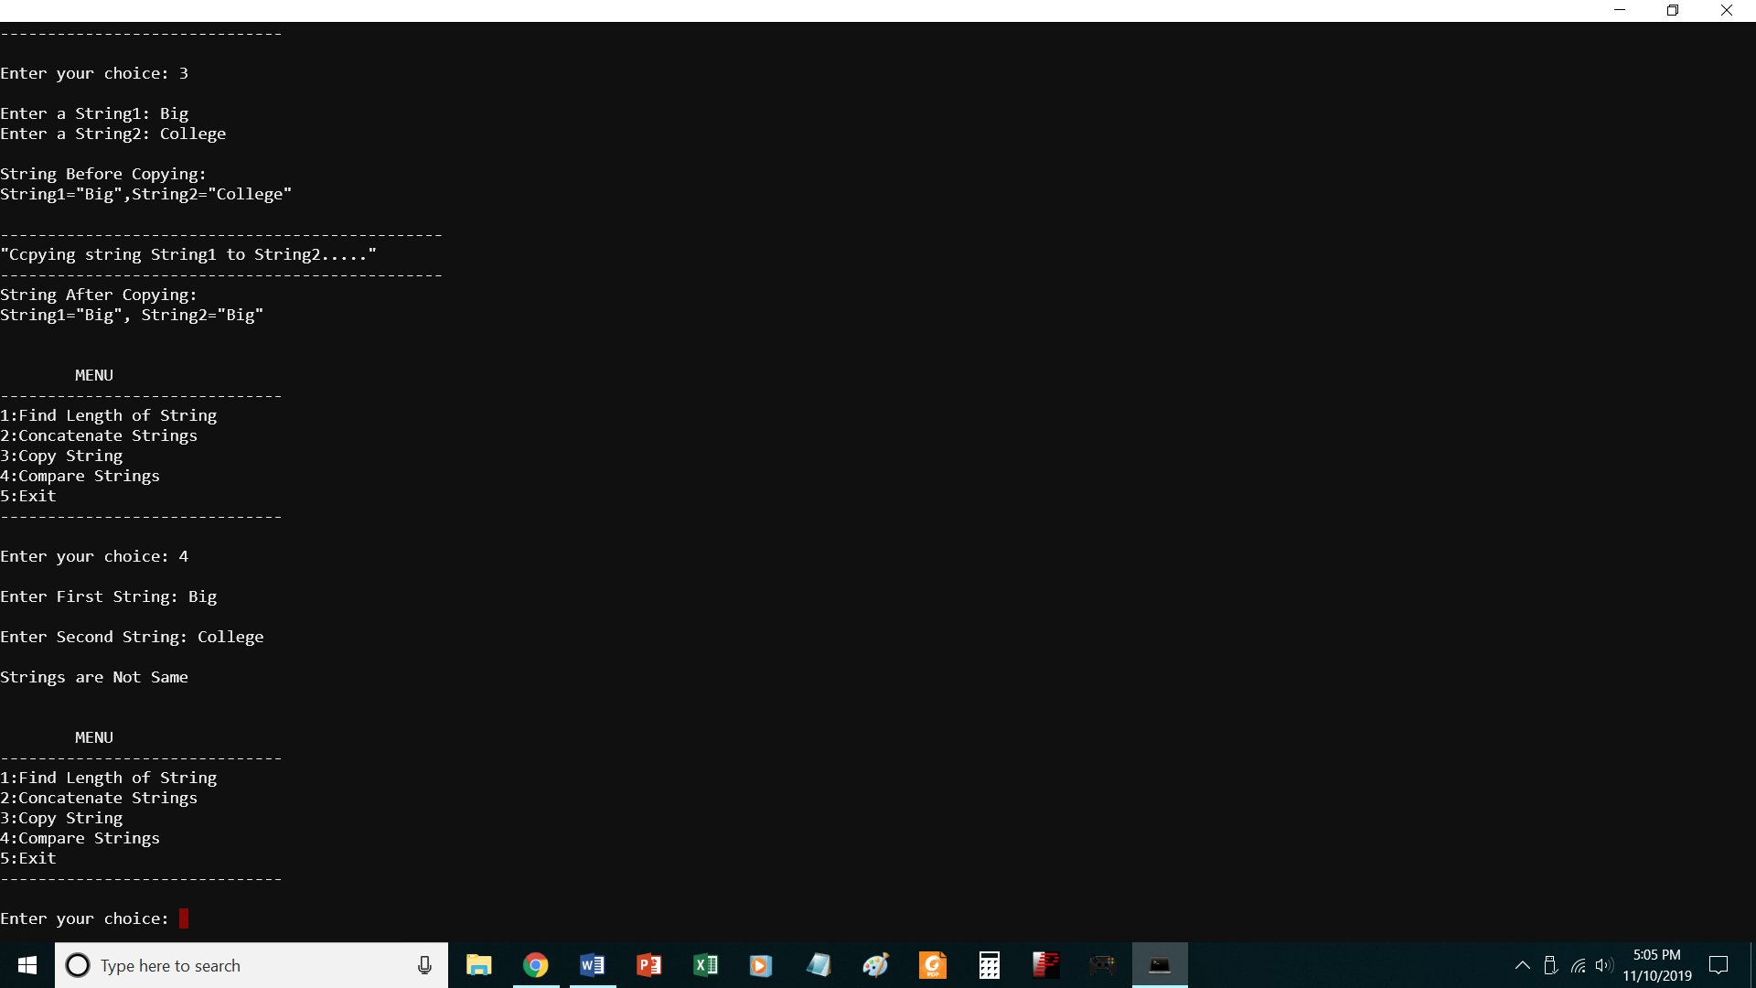

// To perform basic string operations

#include<stdio.h>

#include<string.h>

#include<stdlib.h>

void main()

{

char str1[20],str2[20];

int ch,i,j;

do

{

printf("\n\tMENU");

printf("\n------------------------------\n");

printf("1:Find Length of String");

printf("\n2:Concatenate Strings");

printf("\n3:Copy String ");

printf("\n4:Compare Strings");

printf("\n5:Exit");

printf("\n------------------------------\n");

printf("\nEnter your choice: ");

scanf("%d",&ch);

switch(ch)

{

case 1:

printf("\nEnter String: ");

scanf("%s",str1);

i=strlen(str1);

printf("\nLength of String : %d\n\n",i);

break;

case 2:

printf("\nEnter First String: ");

scanf("%s",str1);

printf("\nEnter Second string: ");

scanf("%s",str2);

strcat(str1,str2);

printf("\nString After Concatenation : %s\n\n",str1);

break;

case 3:

printf("\nEnter a String1: ");

scanf("%s",str1);

printf("Enter a String2: ");

scanf("%s",str2);

printf("\nString Before Copying:\nString1=\"%s\",String2=\"%s\"\n",str1,str2);

strcpy(str2,str1);

printf("\n-----------------------------------------------\n");

printf("\"Ccpying string String1 to String2.....\" \n");

printf("-----------------------------------------------\n");

printf("String After Copying:\nString1=\"%s\", String2=\"%s\"\n\n",str1,str2);

break;

case 4:

printf("\nEnter First String: ");

scanf("%s",str1);

printf("\nEnter Second String: ");

scanf("%s",str2);

j=strcmp(str1,str2);

if(j==0)

{

printf("\nStrings are Same\n\n");

}

else

{

printf("\nStrings are Not Same\n\n");

}

break;

case 5:

exit(0);

break;

default:

printf("\nInvalid Input. Please Enter valid Input.\n\n ");

}

}while(ch!=5);

}

P26.c

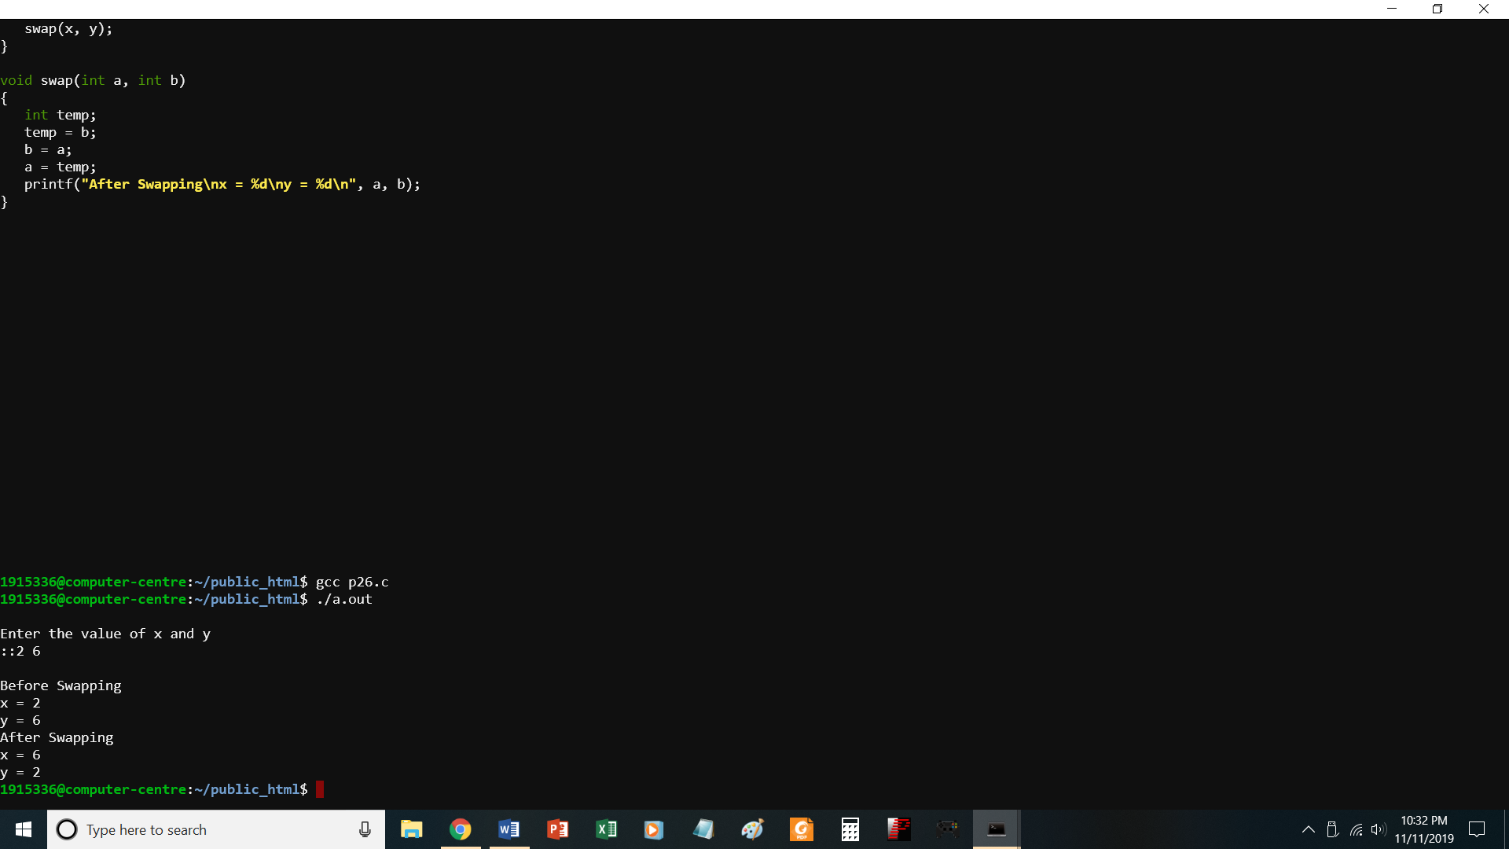

//PROGRAM TO SWAP TWO NUMBERS USING CALL BY VALUE

# include <stdio.h>

void swap(int, int);

int x,y;

void main()

{

//int x, y;

printf("\nEnter the value of x and y\n::");

scanf("%d %d",&x,&y);

printf("\nBefore Swapping\nx = %d\ny = %d\n", x, y);

swap(x, y);

}

void swap(int a, int b)

{

int temp;

temp = b;

b = a;

a = temp;

printf("After Swapping\nx = %d\ny = %d\n", a, b);

}

P26-1.c

Print numbers using call by reference

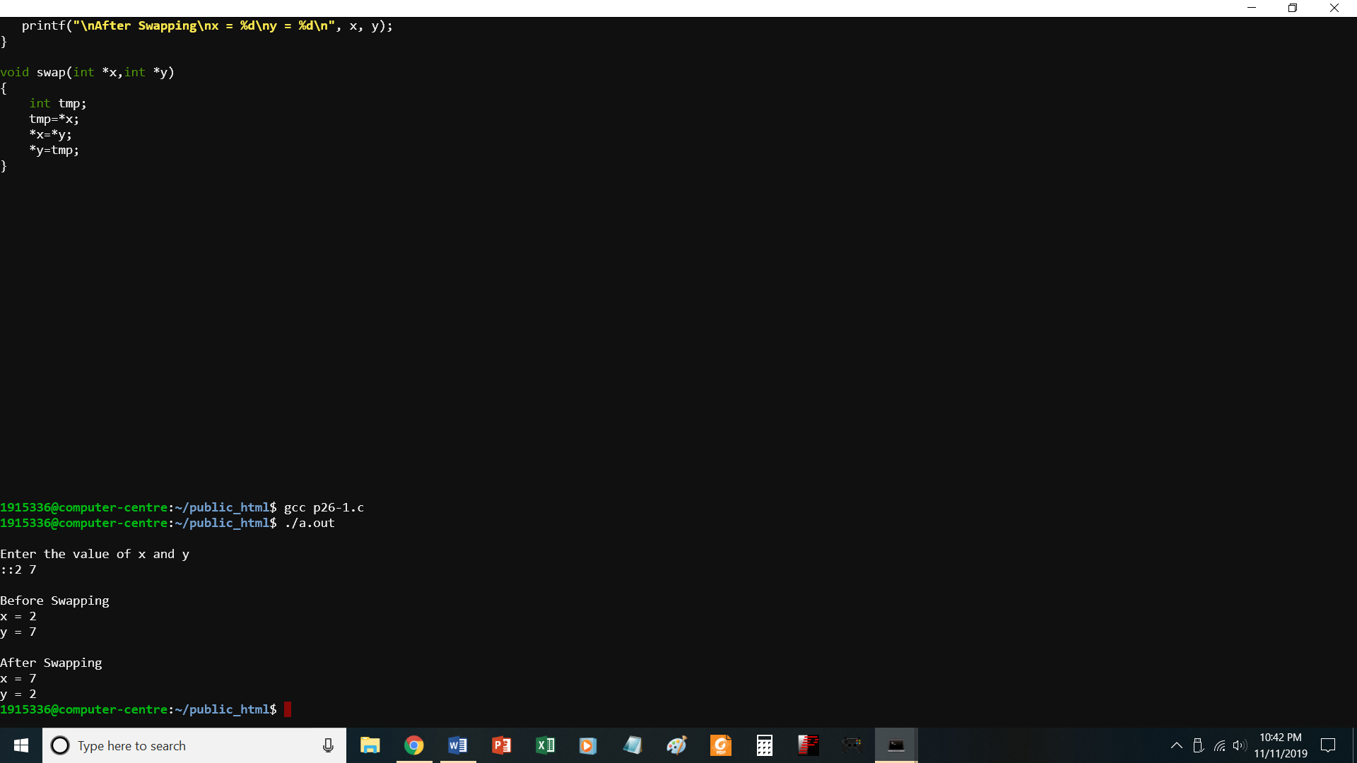

//PROGRAM TO SWAP TWO NUMBERS USING CALL BY REFERENCE

# include <stdio.h>

void swap(int *, int *);

int x,y;

void main()

{

//int x, y;

printf("\nEnter the value of x and y\n::");

scanf("%d %d",&x,&y);

printf("\nBefore Swapping\nx = %d\ny = %d\n", x, y);

swap(&x,&y);

printf("\nAfter Swapping\nx = %d\ny = %d\n", x, y);

}

void swap(int *x,int *y)

{

int tmp;

tmp=*x;

*x=*y;

*y=tmp;

}

P27-1.c

To find factorial of a number without using recursion

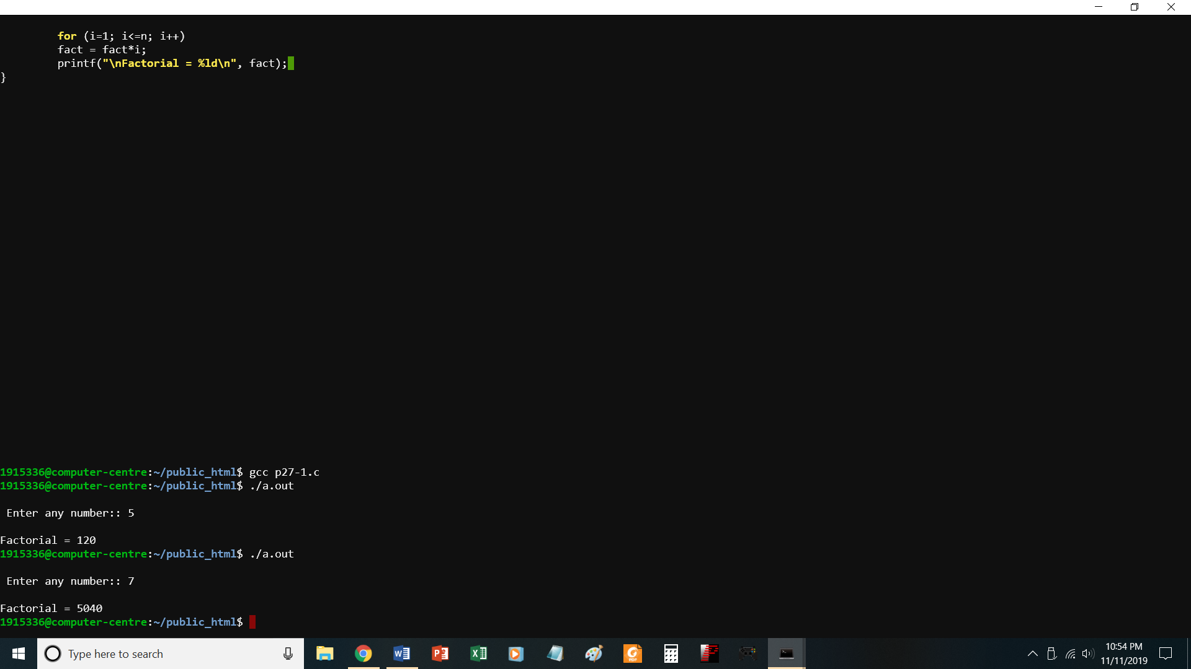

//PROGRAM TO FIND FACTORIAL OF A NUMBER WITHOUT USING RECURSION

#include <stdio.h>

void main()

{

int n, i;

printf("\n Enter any number:: ");

scanf("%d", &n);

for (i=1; i<=n; i++)

fact = fact*i;

printf("\nFactorial = %ld\n", fact);

}

P27-.c

Factorial of a number using recursion

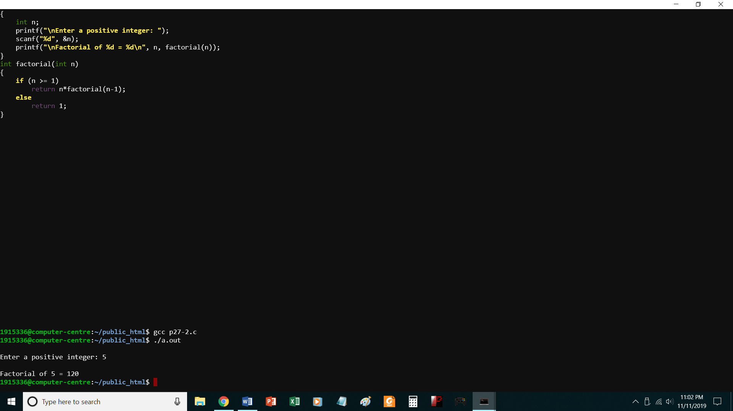

//PROGRAM TO FIND FACTORIAL OF A NUMBER USING RECURSION

#include <stdio.h>

int factorial(int n);

void main()

{

int n;

printf("\nEnter a positive integer: ");

scanf("%d", &n);

printf("\nFactorial of %d = %d\n", n, factorial(n));

}

int factorial(int n)

{

if (n >= 1)

return n*factorial(n-1);

else

return 1;

}

P28-1.c

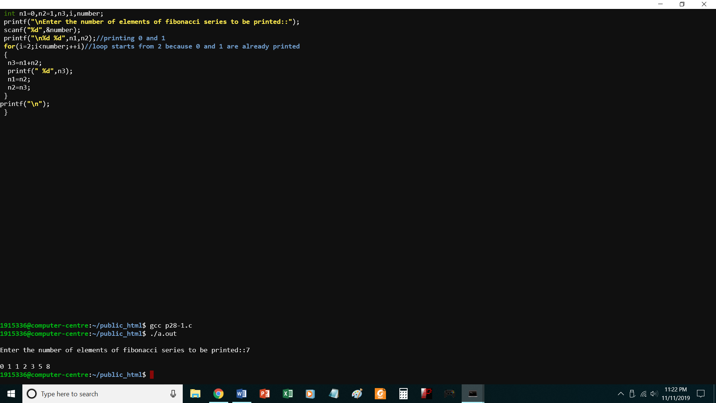

// Print Fibonacci series without recursion

#include<stdio.h>

void main()

{

int n1=0,n2=1,n3,i,number;

printf("\nEnter the number of elements of fibonacci series to be printed::");

scanf("%d",&number);

printf("\n%d %d",n1,n2);//printing 0 and 1

for(i=2;i<number;++i)//loop starts from 2 because 0 and 1 are already printed

{

n3=n1+n2;

printf(" %d",n3);

n1=n2;

n2=n3;

}

printf("\n");

}

P28-2.C

PRINT FIBONACCI SERIES USING RECURSION

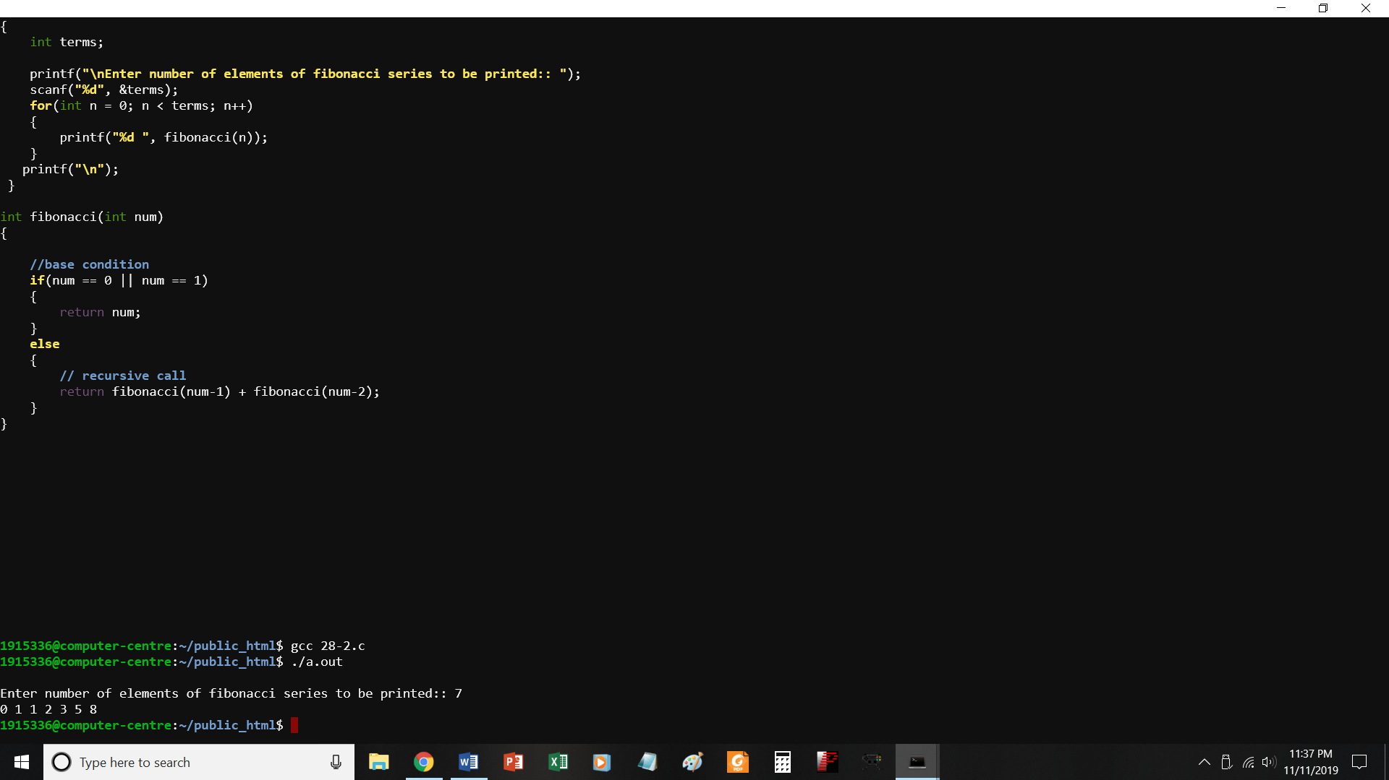

//PROGRAM TO PRINT FIBONACCI SERIES USING RECURSION

#include<stdio.h>

int fibonacci(int);

void main()

{

int terms;

printf("\nEnter number of elements of fibonacci series to be printed:: ");

scanf("%d", &terms);

for(int n = 0; n < terms; n++)

{

printf("%d ", fibonacci(n));

}

printf("\n");

}

int fibonacci(int num)

{

//base condition

if(num == 0 || num == 1)

{

return num;

}

else

{

// recursive call

return fibonacci(num-1) + fibonacci(num-2);

}

}

P29.c

Print average of 5 numbers using recursion

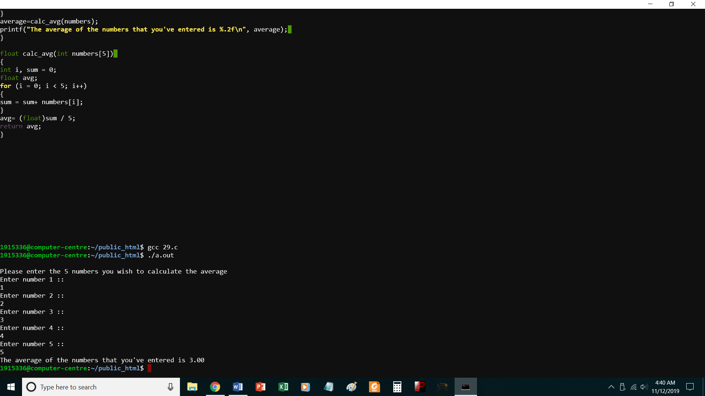

//PROGRAM TO CALCULATE AVERAGE OF 5 NUMBERS USING FUNCTIONS

#include<stdio.h>

float calc_avg(int[]);

void main()

{

int i;

int numbers[5];

float average;

printf("\nPlease enter the 5 numbers you wish to calculate the average\n");

for (i = 0; i < 5; i++)

{

printf("Enter number %d :: \n",i+1);

scanf("%d", &numbers[i]);

}

average=calc_avg(numbers);

printf("The average of the numbers that you've entered is %.2f\n", average);

}

float calc_avg(int numbers[5])

{

int i, sum = 0;

float avg;

for (i = 0; i < 5; i++)

{

sum = sum+ numbers[i];

}

avg= (float)sum / 5;

return avg;

}

P30.c perform linear and binary search

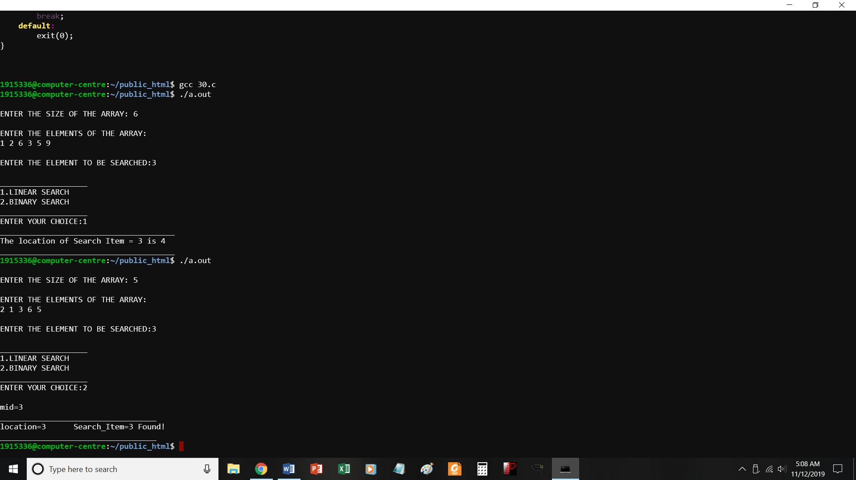

//Program to implement linear search and Binary search */

#include <stdio.h>

#include <stdlib.h>

void main()

{

int array[10],search_item,i,j,n,low,high,location,choice;

void linear_search(int search_item,int array[10],int n);

void binary_search(int search_item,int array[10],int n);

/* read the elements of array */

printf("\nENTER THE SIZE OF THE ARRAY: ");

scanf("%d",&n);

printf("\nENTER THE ELEMENTS OF THE ARRAY:\n");

for(i=1;i<=n;i++)

{

scanf("%d",&array[i]);

}

/* Get the Search element */

printf("\nENTER THE ELEMENT TO BE SEARCHED:");

scanf("%d",&search_item);

/* Choice of Search Algorithm */

printf("\n___________________\n");

printf("1.LINEAR SEARCH\n");

printf("2.BINARY SEARCH\n");

printf("___________________\n");

printf("ENTER YOUR CHOICE:");

scanf("%d",&choice);

switch(choice)

{

case 1:

linear_search(search_item,array,n);

break;

case 2:

binary_search(search_item,array,n);

break;

default:

exit(0);

}

/* LINEAR SEARCH */

void linear_search(int search_item,int array[10],int n)

{

int i,location;

for(i=1;i<=n;i++)

{

if(search_item == array[i])

{

location = i;

printf("______________________________________\n");

printf("The location of Search Item = %d is %d\n",search_item,location);

printf("______________________________________\n");

}

}

}

/* Binary Search to find Search Key */

void binary_search(int search_item,int array[10],int n)

{

int mid,i,low,high;

low = 1;

high = n;

mid = (low + high)/2;

printf("\nmid=%d\n",mid);

i=1;

while(search_item != array[mid])

{

if(search_item <= array[mid])

{

low = 1;

high = mid+1;

mid = (low+high)/2;

}

else

{

low = mid+1;

high = n;

mid = (low+high)/2;

}

}

printf("__________________________________\n");

printf("location=%d\t",mid);

printf("Search_Item=%d Found!\n",search_item);

printf("__________________________________\n");

}

P31.c

To perform bubble sort

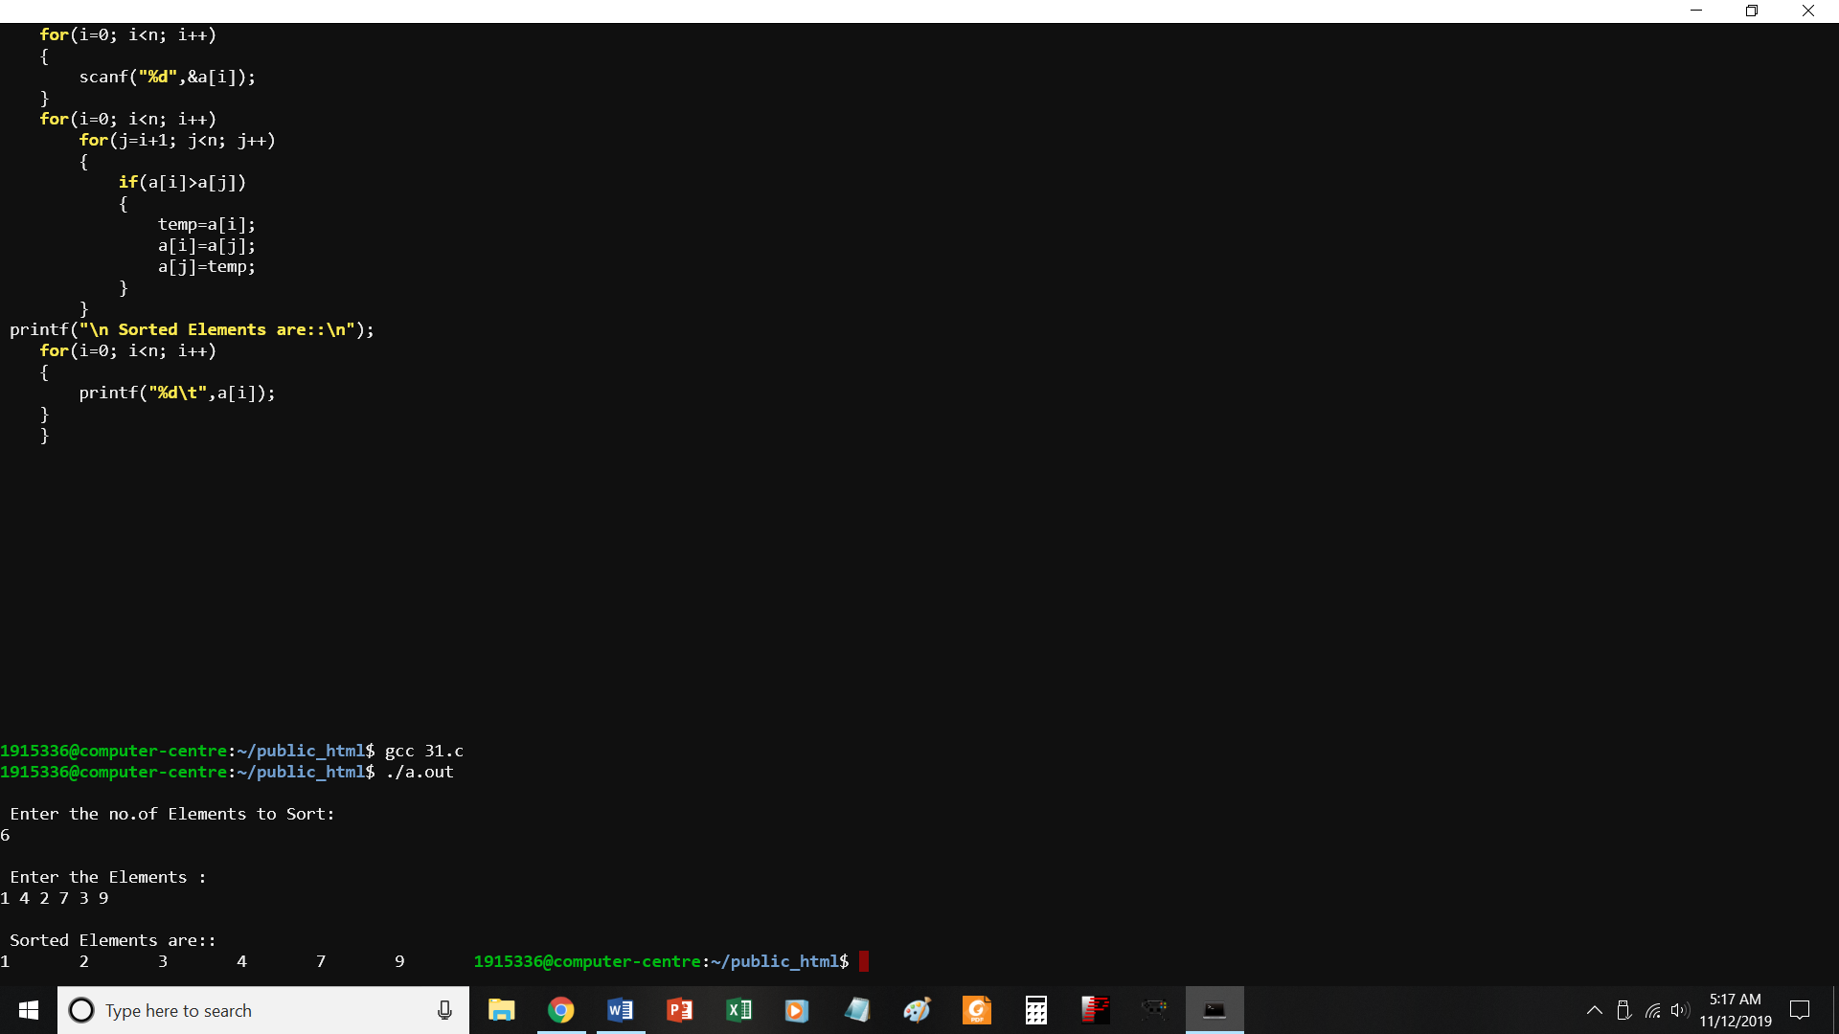

//PROGRAM TO IMPLEMENT BUBBLE SORT

#include<stdio.h>

void main()

{

int a[10],i,j,temp,n;

printf("\n Enter the no.of Elements to Sort: \n");

scanf("%d",&n);

printf("\n Enter the Elements : \n");

for(i=0; i<n; i++)

{

scanf("%d",&a[i]);

}

for(i=0; i<n; i++)

for(j=i+1; j<n; j++)

{

if(a[i]>a[j])

{

temp=a[i];

a[i]=a[j];

a[j]=temp;

}

}

printf("\n Sorted Elements are::\n");

for(i=0; i<n; i++)

{

printf("%d\t",a[i]);

}

}

P32.c

Store info of 10 students using array of structures

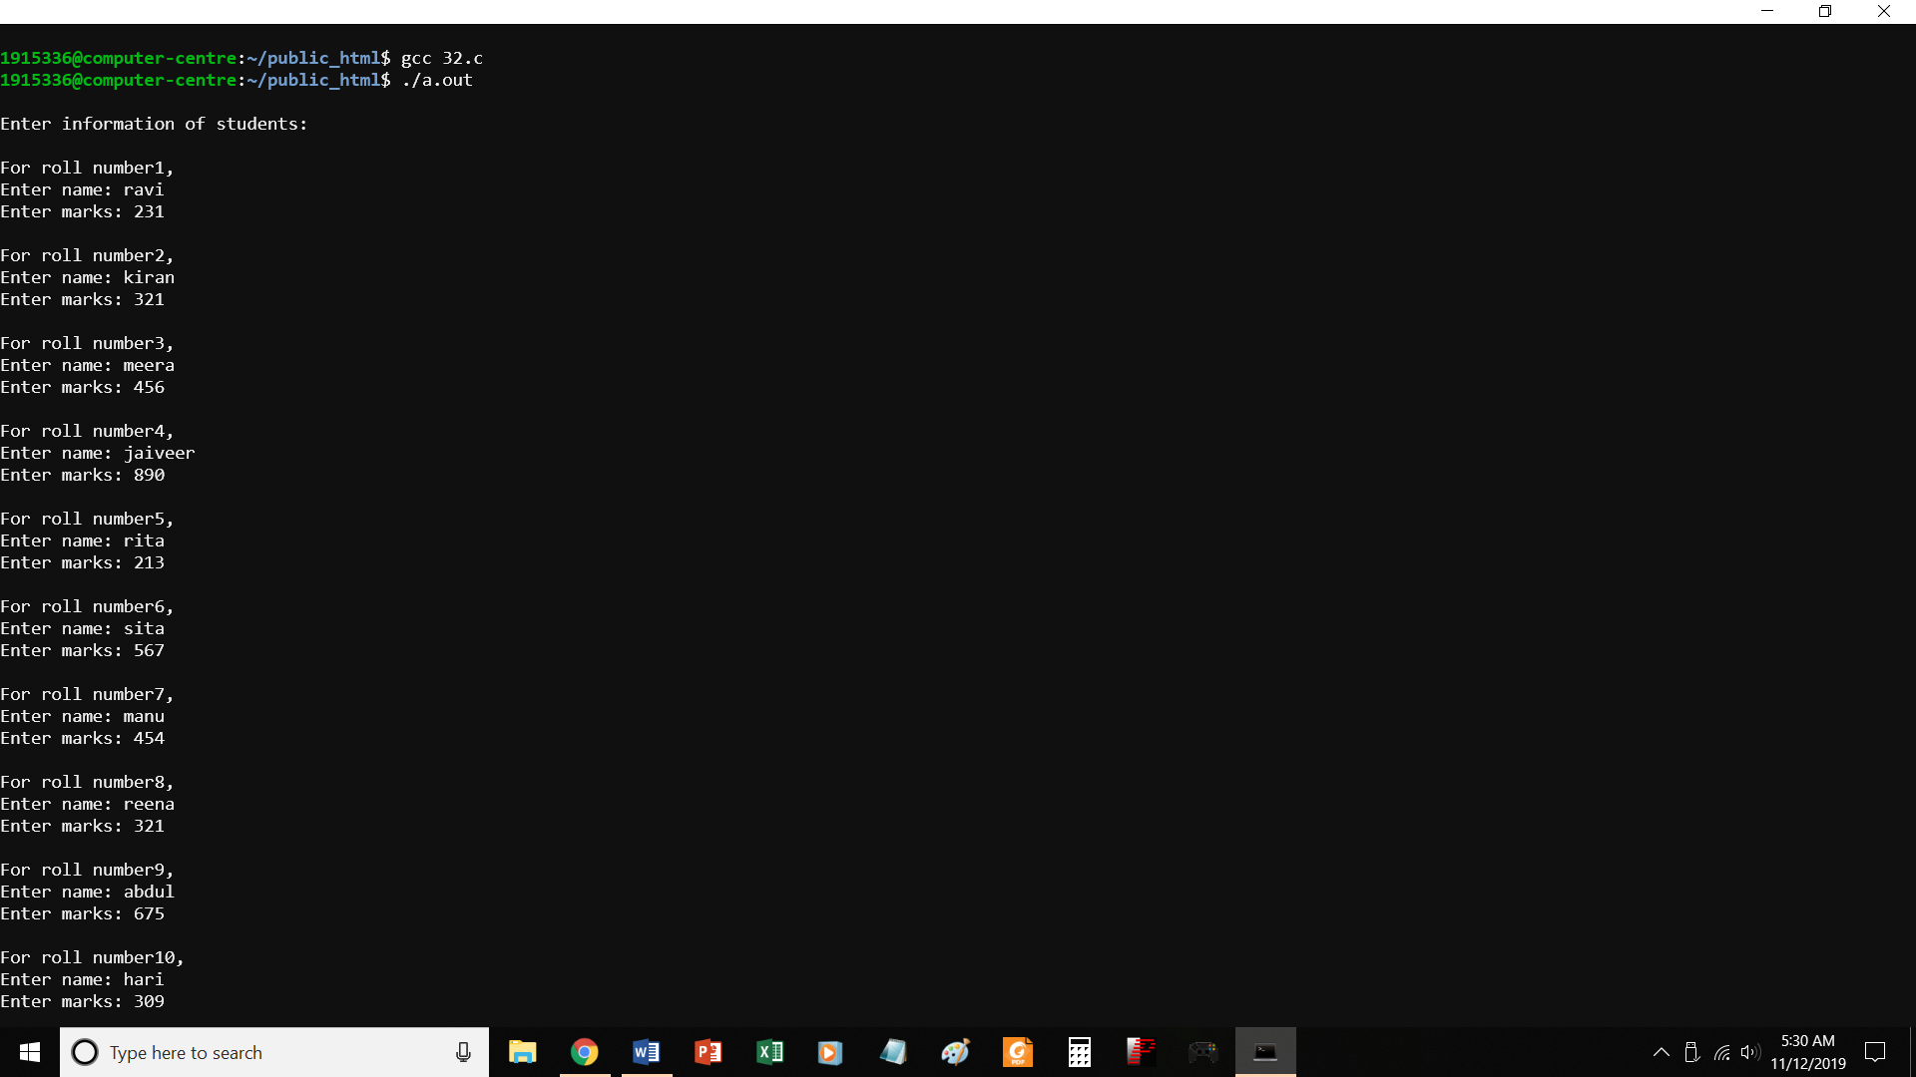

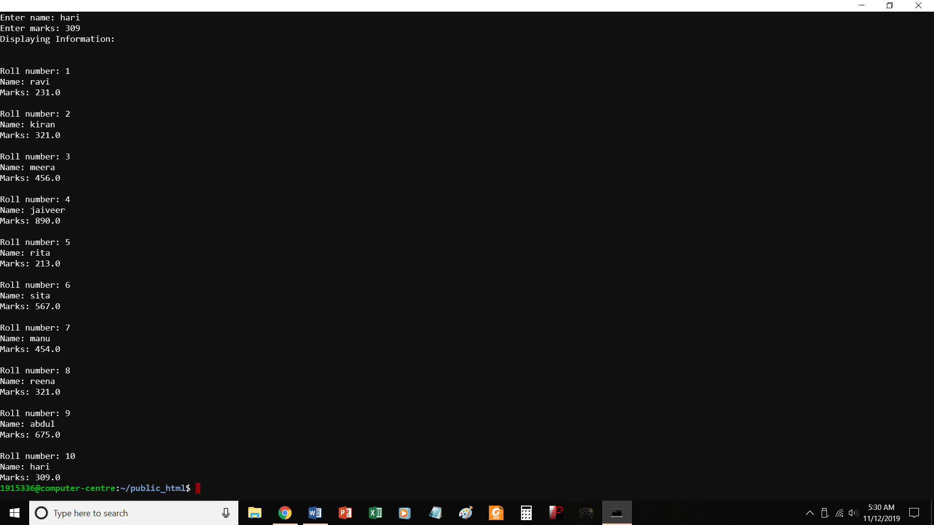

//PROGRAM TO STORE INFO OF 10 STUDENTS USING ARRAY OF STRUCTURES

#include <stdio.h>

struct student

{

char name[50];

int roll;

float marks;

} s[10];

void main()

{

int i;

printf("\nEnter information of students:\n");

// storing information

for(i=0; i<10; ++i)

{

s[i].roll = i+1;

printf("\nFor roll number%d,\n",s[i].roll);

printf("Enter name: ");

scanf("%s",s[i].name);

printf("Enter marks: ");

scanf("%f",&s[i].marks);

// printf("\n");

}

printf("Displaying Information:\n\n");

// displaying information

for(i=0; i<10; ++i)

{

printf("\nRoll number: %d\n",i+1);

printf("Name: ");

puts(s[i].name);

printf("Marks: %.1f",s[i].marks);

printf("\n");

}

}

P33.c

Program to print transpose of a matrix

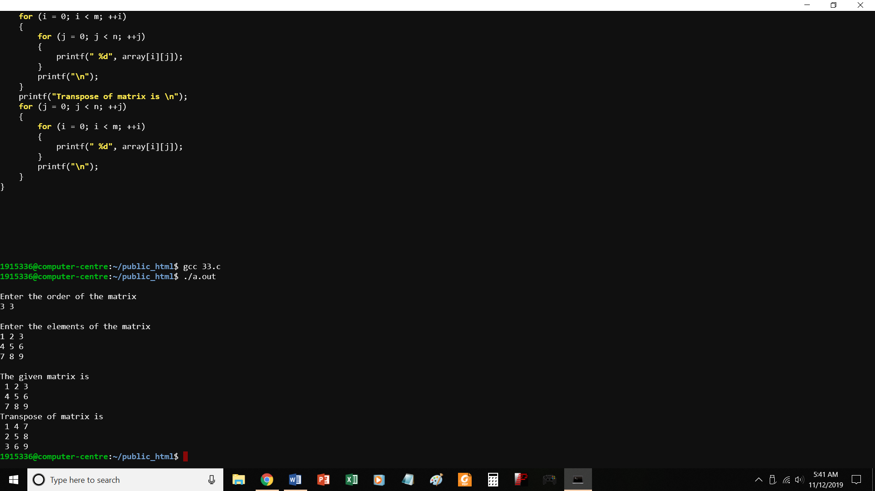

//PROGRAM TO PRINT TRANSPOSE OF A MATRIX

#include <stdio.h>

void main()

{

static int array[10][10];

int i, j, m, n;

printf("\nEnter the order of the matrix \n");

scanf("%d %d", &m, &n);

printf("\nEnter the elements of the matrix\n");

for (i = 0; i < m; ++i)

{

for (j = 0; j < n; ++j)

{

scanf("%d", &array[i][j]);

}

}

printf("\nThe given matrix is \n");

for (i = 0; i < m; ++i)

{

for (j = 0; j < n; ++j)

{

printf(" %d", array[i][j]);

}

printf("\n");

}

printf("Transpose of matrix is \n");

for (j = 0; j < n; ++j)

{

for (i = 0; i < m; ++i)

{

printf(" %d", array[i][j]);

}

printf("\n");

}

}

P34.C

PRINT ADDRESS OF VARIABLES USING POINTERS

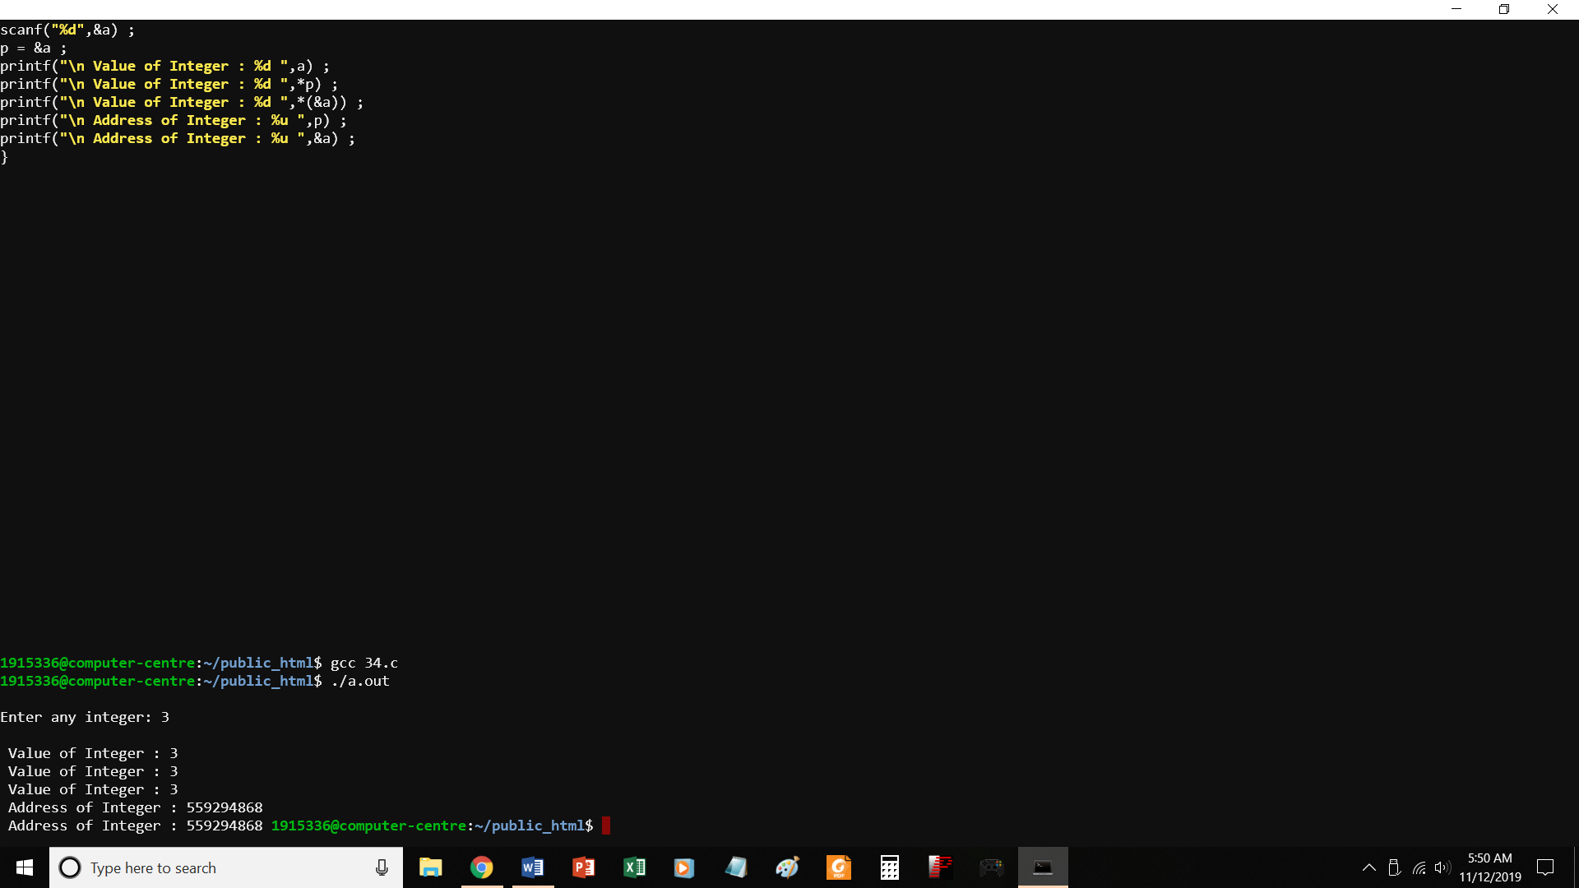

//PROGRAM TO PRINT ADDRESS OF VARIABLES USING POINTERS

#include <stdio.h>

void main( )

{

int a ;

int *p ;

printf("\nEnter any integer: ") ;

scanf("%d",&a) ;

p = &a ;

printf("\n Value of Integer : %d ",a) ;

printf("\n Value of Integer : %d ",*p) ;

printf("\n Value of Integer : %d ",*(&a)) ;

printf("\n Address of Integer : %u ",p) ;

printf("\n Address of Integer : %u ",&a) ;

}

P35.c Access array elements using pointers

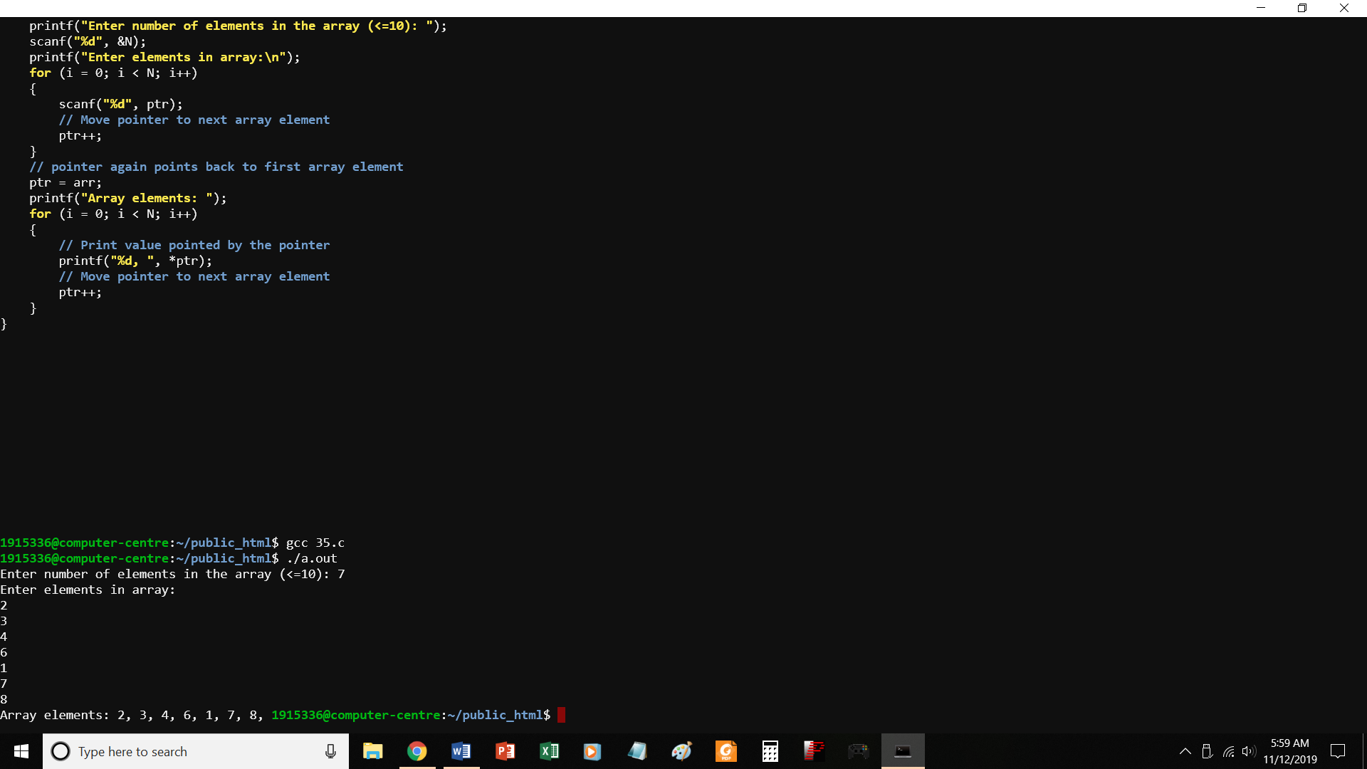

//PROGRAM TO ACCESS ARRAY ELEMENTS USING POINTERS

#include <stdio.h>

void main()

{

int arr[10];

int N, i;

int * ptr = arr; // Pointer to arr[0]

printf("Enter number of elements in the array (<=10): ");

scanf("%d", &N);

printf("Enter elements in array:\n");

for (i = 0; i < N; i++)

{

scanf("%d", ptr);

// Move pointer to next array element

ptr++;

}

// pointer again points back to first array element

ptr = arr;

printf("Array elements: ");

for (i = 0; i < N; i++)

{

// Print value pointed by the pointer

printf("%d, ", *ptr);

// Move pointer to next array element

ptr++;

}

}